

**Database Management System Project**

Final Report

**Group - 04 (Wall Breaker)**

|  |  |  |
| --- | --- | --- |
| **Name** | **ID** | **Section** |
| Md. Akram Hossain | 1830707 | 04 |
| Md. Adib Al Supto | 1921719 | 04 |
| Ishraque Rahman | 1930426 | 04 |
| Md. Asif Intesar | 2022430 | 04 |
| Md. Abdullah Al Hasan | 2030467 | 04 |
| Nahin Fatima | 2030657 | 04 |

**Contents**

**CHAPTER 1 -**

INTRODUCTION:..............................................................................................................................................3

A. BACKGROUND OF THE ORGANIZATION- IUB: .................................................................................. 4

B. BACKGROUND OF THE PROJECT SPMS 3.0......................................................................................... 4

C. OBJECTIVE OF THE PROJECT SPMS 3.0: .............................................................................................. 5

D. SCOPE OF THE PROJECT:......................................................................................................................... 5

**CHAPTER 2 - REQUIREMENT**

ANALYSIS:....................................................................................................................................................... 6

A. RICH PICTURE – EXISTING BUSINESS SYSTEM:............................................................................... 6

B. SIX ELEMENTS ANALYSIS - EXISTING BUSINESS SYSTEM:.......................................................... 8

C. PROCESS MODEL – EXISTING BUSINESS SYSTEM:..........................................................................22

**D. PROBLEM ANALYSIS – EXISTING BUSINESS SYSTEM:**...............................................................22

E. RICH PICTURE - PROPOSED SYSTEM:..................................................................................................22

F. SIX ELEMENTS ANALYSIS – PROPOSED SYSTEM :............................................................................23

G. PROCESS MODEL - PROPOSED SYSTEM:.............................................................................................32

**CHAPTER 3 - LOGICAL SYSTEM**

DESIGN:............................................................................................................................................................32

A. BUSINESS RULE [ SPMS 3.0 ]:..................................................................................................................32

B. ENTITY RELATIONSHIP DIAGRAM:.......................................................................................................34

C. ENTITY RELATIONSHIP DIAGRAM TO RELATIONAL SCHEMA:.....................................................35

D. NORMALIZATION:.....................................................................................................................................36

E. DATA DICTIONARY: ..................................................................................................................................41

**CHAPTER 4 - PHYSICAL SYSTEM DESIGN:**

A. INPUT FORM:..............................................................................................................................................76

B. OUTPUT FORMS:........................................................................................................................................81

**CHAPTER 5**

CONCLUSION:................................................................................................................................................130

A. PROBLEM AND SOLUTION:.....................................................................................................................130

B. ADDITIONAL FEATURE AND FUTURE DEVELOPMENT:..................................................................130

REFERENCES-..................................................................................................................................................13

**CHAPTER 1 - INTRODUCTION:**

The Independent University, Bangladesh (IUB) has robust and versatile schools - notably consisting of the following:

**● Business & Entrepreneurship**

**● Engineering, Technology & Sciences**

**● Environment and Life Sciences**

**● Liberal Arts & Social Sciences**

**● Pharmacy and Public Health.**

The university has been an active participant in the growth of the education sector in Bangladesh and has produced capable and knowledgeable scholars contributing both here and abroad. [1] IUB has achieved this through working closely with relevant government education institutions and organizations such as the University Grants Commission (UGC),Ministry of Education, and other necessary institutes for each of the schools, regular updating its curriculums and putting in a system to monitor student performance based on a quantified approach between course curriculum and standards set by UGC and the Bangladesh government and constantly tracking student performance for every semester – mainly, using Outcome-Based Education (OBE) for monitoring performance and setting university curriculum. [1]

The focus of this report is to study the current student performance monitoring system that IUB uses, do the required analysis of its processes, and propose a new and better improved system that reduces error, makes analysis of data and report generation easier by all vested quarters and produce/show valuable information needed for IUB and its collaborators in making necessary improvements in academia to produce better scholars. The first part focuses on the details of the organization in question and the project that we have undertaken for it. The second part focuses on the existing system and its shortcomings and an introduction of the proposed system that we plan to replace the existing system with. The third and fourth will be heavily technical and focus on how we plan to bring the proposed system into being.During our research into the existing system for student performance monitoring we have found many areas where valuable changes could be made to make each process of monitoring student performance faster, make communication between necessary stakeholders easier, take away chances for errors and data duplication, and most importantly make it easier for all stakeholders to easily surf through large datasets to get meaningful information to their requirement. As we go through this report, we will dig deeper into how the current student performance monitoring system operates, the business processes involved, where there are concerns and issues related to data management, and how we can make a better system to address these issues for fixing and improvement.

**A. BACKGROUND OF THE ORGANIZATION- IUB:**

Independent University, Bangladesh (IUB), established in 1993, is one of the oldest private universities in Bangladesh, currently has more than an estimated 7,048 undergraduate and graduate students and over 10,455 alumni. This student population is mostly predicted to grow at 10% annually. [2]IUB, over-time, has shown remarkable outcomes in producing graduates with marketable skills only because of staying disciplined and up to date with the on-going curriculum and progress system. Dedicating attention towards IUB’s Departments, and more specifically focusing the Department of Computer Science and Electrical science into a well-funded research hub running several research projects. IUB is also committed to curve potential graduates of international standard who are mainly equipped to provide new leadership to the national economy through skilled employment, entrepreneurship and/or applied research. This is successful due to the overwhelming support of the Bangladesh Government and the UGC for IUB to be able to create state-of-the-art lab facilities in their department. It is because of IUB’s approach to academics as an “Application Oriented Learning” philosophy that “not only teaches students the fundamental principles of learning, situation -handling, and have better overall perception by providing them with hands-on training sessions.” [3] Continuously growing it’s lab facilities and flourishing on its curriculum according to current market economic demands, the SECS and the Department of Computer Science and Engineering at IUB has constantly worked with IEB, UGC and the Ministry of Education to track their students overall performance under specific periods by quantifying specific courses and its relating assessments into measurable trackers to gain valuable insights for improvement of students over

the years as a student in a certain department. These processes and criteria credentials courses are ultimately set by IEB along with relevant government potentials to set the bar for up-coming graduating engineers from top universities in Bangladesh. These sets of standards come in the form of Program Educational Objectives (PEO)and Program Learning Outcomes (PLO) [1] for specific departments in an Accreditation Manual which are mapped to specific courses by relevant Course Instructors and Co-Ordinator. This allows the Department of CSE at IUB, SECS, IEB and all other relevant stakeholders to have a calculating assessment of the current state-of-affairs and the performance of each student under each course for every semester. This will also allow users to track performance of faculties, courses, departments and schools and provides valuable insight for making necessary improvements.

**B. BACKGROUND OF THE PROJECT SPMS 3.0:**

Measuring the output of students, faculties, departments, and their respective courses in order to measure their productivity in regard to the outcome relevance of the course activities. Basically, to provide a range of tools and data intended to help universities and education authorities such as IEB, UGC, as well as other stakeholders to evaluate the performance of students and inform strategies for improvements. Developing a national framework for Outcome-Based Education while at the same time leaving considerable freedom to universities in implementing local approaches.

**C. OBJECTIVE OF THE PROJECT SPMS 3.0:**

The SPMS 3.0 system monitors and summarizes the performances of the stakeholders - students,faculties, schools, and departments through the database of the assessments. For evaluation purposes the system would be able to store individual assessment marks (midterm, quizzes, assignment, projects, presentations and so on). As well as the marks of those assessments with respect to their Course Outcomes (CO) and Program Learning Outcomes (PLO) accordingly in the database of the system to observe the outcome and performance of the student’s faculties, schools, and departments.

The students being the primary stakeholder, would be able to statistically directly monitor the overall performance to their satisfaction of certain course objectives. Hence based on their performances and faculty evaluation the higher stakeholders (Head of department and Admin) can understand and manage the degree in comparison to which different course outcomes targets and their achievements are being understood by the student, department, school, and university body as a whole. SPSMS 2.0 also monitors the impact of policies against overall administrative goals and targets by the system. The system’s main target is to monitor the whole university activities through the database and produce analytics for the Head of Department, Faculty, School, Students, and their Courses in a given period of time (yearly and semester wise).

**D. SCOPE OF THE PROJECT:**

We did a complete analysis of the existing system and found out places in the business processes which can cause severe lapses in time and communication, which we will discuss in the next chapter.

Our solution is to create a Web application, called SPMS 3.0 (Student Performance Monitoring System 3.0), using a Relational Database Management System (RDMS) to store, edit, add, and update necessary data for monitoring student performance and producing and storing related OBE data, reports, and documents. We produced potential users for the web based SPMS 3.0 system and speculated how they would be using the system and the necessary information and data they would need access to. Since the problems can arise from many points of all business processes, we will make custom user interfaces and login capabilities for all stakeholders who will also be the users of this system. Since we use a (RDBMS) for data storage, retrieving necessary files, tabular data, page layouts and reports becomes incredibly easy and allows us to interact with the necessary data to occur real- time. We also create interfaces for all users to easily access these data and use them to generate and download reports. We build an interface for faculties to be able to collaborate with each other on developing course outlines, course reports, marksheets, assessments, mapping assessments to CO’s and PLOs for PLO achievements, and record assessments of students throughout the semester for all their courses.

Students, the IUB leadership team and government agencies can also access the systems for drawing conclusions. Data will also be protected, and each stakeholder will be shown only that data, which is relevant to them, respectively.

**CHAPTER 2 - REQUIREMENT ANALYSIS:**

The Requirement Analysis is the process of researching and visualizing the current system and processes that go into the business operation of a specific organization using industry tools, methods, and standards. "The process of determining what the database will be used for is known as requirements analysis." It entails conducting interviews with user groups and other stakeholders to determine what functionality the database needs to provide, what types of data they want to process, and the most frequently performed operations." [4]

This allows us to observe each stakeholder and how they interact with one another. We use simple notations and symbols to explain how a business process works and how to dissect it.

As we shall see, this approach of analysis enables us to identify both obvious and less obvious issues with a current manual system of student performance monitoring that relies on the involvement of stakeholders and third party actors producing faults in the system.

**A. RICH PICTURE – EXISTING BUSINESS SYSTEM:**

A Rich Picture is a method for investigating, acknowledging, and defining a business process and then expressing it using diagrams to produce a rough mental model. A detailed description facilitates conversation and leads to a comprehensive knowledge that is shared by all parties. [5] The comprehensive image that is produced can help other stakeholders understand the issues with a current system while also allowing them to take into account a wide range of relevant factors. Rich images focus on the processes and structure of a particular setting. [6]

The Rich Picture Analysis also takes into account the following:

**· Structures**

**· Processes**

**· Climate**

**· People**

**· Issues expressed by people.**

**· Conflict**

As we can see, these factors were specifically taken into consideration when creating this rich image.

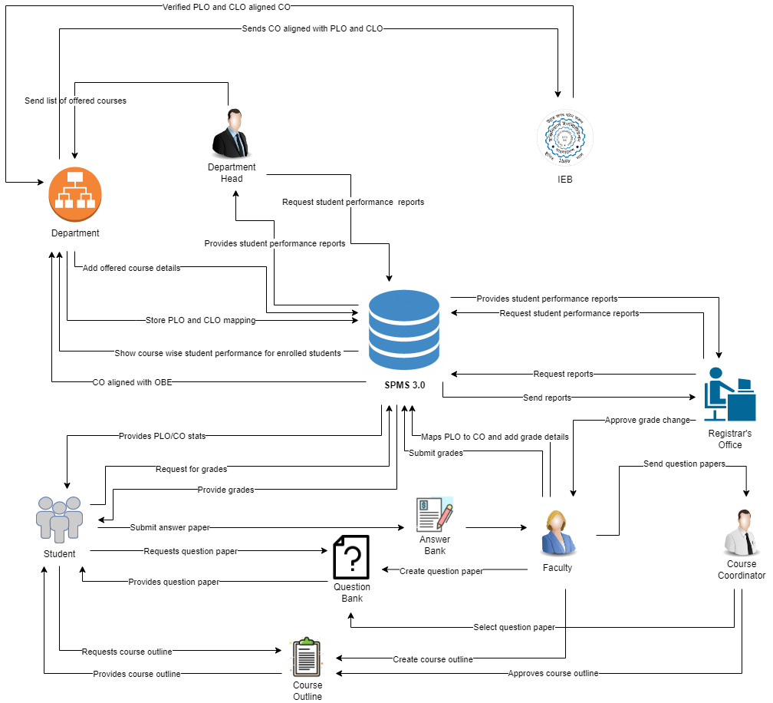

Figure 1.0: Rich Picture of Existing System to Monitor SPMS.

**According to the Rich Picture Analysis, we have the following categories of stakeholders:**

1. IEB
2. Head of Department/Dean of School
3. Department (working under Head of Department/Dean of School)
4. Faculty
5. Course Coordinators
6. Registrar’s Office
7. Admin (working under Registrar’s Office)
8. Students

**We can also distinguish three different storage facilities or systems, namely:**

1. The Department Storage
2. The Registrar’s Office Storage
3. SPMS

**We have identified seven processes from this "Rich Picture" that are essential to tracking student progress and enhancing the curriculum. These are the procedures:**

1. Map Course Outcomes (COs) to Program Learning Outcomes (PLOs).
2. Record Student Course Performance Data.
3. View Course Reports over a given time-period for inspection and

analysis of student performance trends.

1. Produce OBE Marksheet & Bloom’s Taxonomy Report.
2. View Records OBE Marksheets, Course .
3. Request for Question Bank files.
4. Request for Course Outlines.

**B. SIX ELEMENTS ANALYSIS - EXISTING BUSINESS SYSTEM:**

The Six Elements Analysis gives a thorough explanation of each element's function in each process. The table below shows that Human entities predominate in all important system functions, particularly in the two processes that are most important—mapping course outcomes and viewing documents related to them. For instance, the current system is heavily reliant on manually processed and handled hardcopy databases. As a result, there is a considerable amount of waiting involved in the interdependent processes before the Human components may perform their obligations.

|  |  |  |  |  |  |  |
| --- | --- | --- | --- | --- | --- | --- |
| **Process** | **System Roles** | | | | | |
|  | **Human** | **Non_computing Hardware** | **Computing Hardware** | **Software** | **Database** | **Network & Communication** |
| **Map Course Outcomes (COs) to Program Learning Outcomes (PLOs).** | **IEB:**  1. Send verified PLO and CLO aligned CO to the Department.  **Department:**  1. Received CO aligned with OBE.  2. Store PLO and CLO mapping.  3. Sends CO aligned with PLO and CLO to IEB.  **Faculty:**  1. List the course material.  2. List the COs.  3. Connect course objectives to course content (COs).  4. Maps PLO to CO.  5. Map COs to specific project work, midterm, and final exam questions.  6. Using the course outline, course content, and COs, begin creating course assessment reports. | **Pen and Paper:**  1. Is utilized for recording more advanced problem-solving ideas.  **Board and Marker:**  1. Is utilized for recording more advanced problem-solving ideas. | **Computer:**  1. Course Coordinators create softcopies of the Course Outcomes (COs) of the particular courses in which they excel using computers.  **Printer:**  1. To print out physical copies of Course Outcomes (COs). | **MS Word:**  1. Course coordinators create detailed course outlines in MS Word and course evaluation reports that map course outcomes (COs) to program learning outcomes (PLOs).  **Excel Sheet:**  1. The course makes use of an Excel sheet. Coordinators will link particular midterm, final exam, and project works to particular course outcomes. |  | **Internal and Email:**  1. To connect with IEB or other stakeholders about crucial issues pertaining to the mapping of course outcomes to program learning outcomes, utilize the internet and email.  **Others:**  Use telephones or other physical contact to have essential conversations with stakeholders about the mapping course. Outcomes to Program Learning Outcomes. |
| **Record Student Course Performance Data.** | **Faculty:**  1. Assign assignments and project work.  2. Complete tests and quizzes all semester long.  3. Keep track of each student's evaluation data for each assessment (tests, assignments, projects, and exams) throughout the semester on both digital and paper copies.  4. Keep track of the scores for every particular question on the midterm and final exams.  5. Determine the combined scores for all assignments, tests, midterms, and finals, then assign final grades to each student in a particular course.  6. Convert midterm and final marks.  7. Enter all of a student's grades for a course into a marksheet.  8. Grade the student.  9. Enter final grades for students on SPMS.  10. Send the Department the Marksheet.  11. Deliver the Marksheet to the Office of the Registrar. | **Pen and Paper:**  1. Record evaluation information and marks in tabular format using a pen and paper (hardcopies). | **Computer:**  1. Computers are used to create softcopies of all assessment data records for certain courses. | **Excel Sheet:**  1. Fill out Excel sheets with the appropriate assessment information and final grades.  **SPMS:**  1. Upload students' final grades to SPMS so that they can view them or have them viewed by the registrar's office. | **Department Storage:**  1. The department office and registrar's office may save copies of student assessment data and final grades for future reference.  **SPMS Database:**  1. Information on student grades is kept and maintained by SPMS using a database server. | **Internet:**  1. To communicate with IRAS and store student final grades, one uses the Internet. |
| **View Course Reports over a given time-period for inspection and**  **analysis of student performance trends.** | **Faculty:**  **a)**Take Assessments for specific courses.  **b)**Send Assessment report to the Head of the Department.  **c)**Announce a date for checking students' performance on the Assessments.  **Students:**  **a)** Check their performance in the given Assignments  **b)** If There is any Query then inform faculty.  **Head of the Department:**  **a)** Check students' Performance reports for the course.  **b)** Send a Performance report to the **CITS**.  **CITS:**  **a)**Preserve the performance report in the database. | **Pen And Paper:**  **a)** Write Down the record of the course report.  **Room:**  **a)** if there is any query in the performance report then come to a specific room to check. | **Computer: a)** Computer used to record the performance report.  b) Students may sign in to Google Classroom.  **Printer:**  **a)** may be printed a copy sent to the Department Head And CITS.  **Google ClassRoom:** Faculty may use Google Classroom to Announce the date of check report.  Mobile | **MS Word:**  **a)**Record the Analysis report in Word.  **Excel Sheet:** Mark All Individual report , Overall report  And make a Spider web of Total Analysis report. | **Department Storage:** Department Storage is being used to record the analysis for comparison to previous semesters. | **Internet:** Faculty use the internet to upload notices for check reports in google classroom. |
| **Produce OBE Marksheet & Bloom’s Taxonomy Report.** | **Faculty:**  1. Calculate  total marks  received for  each CO by  calculating the marks received for questions  and/or other  Assessments  mapped to  CO’s.  2. Calculate  total  percentages  received for  each COs on  the OBE  Marksheet.  3. Declare if a student has  achieved a  specific CO (if CO percentage is greater than or equal to 40). 4. Declare if a student has  received a  PLO for a  related CO.  5. Make a table giving the  verdict and  analysis of  how many  students were  able to receive a certain CO  and PLO and other  documents  containing  necessary  information  and data.  6. Design  Course  Assessment  Report  using Course Outline,  Course  Content  and Course  Outcomes.  7. Send the  final version of the OBE  Marksheet to the Dept.  Office.  **Department**  **Office:**  1. Send the  OBE  marksheet,  Course  Assessment  Report and  others to the  Registrar’s  Office.  2. Store the  OBE  Marksheet and Course  Assessment  Report in the department.  **Registrar’s**  **Office:**  1. Stores the  OBE  Marksheet and Course  Assessment  Reports and  other  documents and reports in the Registrar's  Office. | **Pen and**  **Paper**  1. OBE  marksheet  Stored in  hardcopy.  Additional  markings  may be made to further  separate  between  students. | **Computer/**  **Phone:**  1. Uses  computers to make  softcopies of  the OBE  Marksheet  and Course  Assessment  Reports.  **Printer:**  1. Print  hardcopies of final versions of the OBE  Marksheets  and Course  Assessment  Reports. | **Coded Excel sheet:**  1.Faculty/Course Coordinator uses  automated  excel sheets to calculate the  student’s  success/  failure in  Achieving  PLOs.  **MS Word:**  1. Used to  make Bloom’s taxonomy  Report  softcopies. | **Department Storage:**  1. Records  of students’ assessment  data and  final grades will be  saved in the department for future  reference.  **Registrar’s Office**  **Storage:**  1. OBE  Marksheets, Course  Assessment Reports and other  documents  submitted by the  department is stored for future  reference. | **Internet/Mail: 1.** An Online  platform (such as Google  Sheets) may be used for  processing the OBE  assessment data spreadsheet and Bloom’s taxonomy datasheet. |
| **View Records OBE Marksheets, Course.** | **Faculty: a)**Make an individual OBE mark sheet for Students.  **b)**Request to CITS to Upload in SPMS.  **Student:**  **a)** Login to IRAS**.**  **b)**Request IRASH to get the report of OBE marksheet.  c) get marksheet  **SPMS:**  a)SPMS got a request to upload an OBE marksheet.  b) Upload Marksheet  c) Got a request from a student to see their marksheet report.  c)Upload Specific marksheet to the student. | **Pen and paper:** Faculty use to note specific students and also mark for the out performers within the Students. | **Computer:**  **a)**Students send request through Computer Using his ID.  **Mobile:** Students send requests through Mobile using his ID.  **Printer:** Faculty may print out the whole performance Coy and discuss in the Classroom | **MS Word:** Faculty Record report in MSW Word.  **Excel Sheet:** For individual performance and mapping ousting performers.  **Web Browser:** Students or faculty both have to go through the web browser to send requests to SPMS.  **PDF Viewer:** when Students send requests to see their marks sheet, The CITS send a PDF copy of mark Sheet. | **Department Storage:** Department Storage is being used to record the analysis for comparison to previous semesters.  **SPMSDatabase:** SPMSpreserve all the Data to the Database so that anytime any student can ask to see his mark Sheet. | **Internet:** To use a Web Browser for Sending request Internet is must needed. |
| **Request for Question Bank files.** | **Faculty:**  1. prepare question papers.  2. Give away the question paper to the course coordinator for selection.  3. Take exams from returned Question papers.  4. Got Script from Students  5. Check exam scripts of students.  **Course Coordinators:**  1. Receive question papers from faculty.  2. Moderate question paper  3.Send selected question paper for exam.  **Students:**  1. Ask for exam’s question papers.  2. Perform exam  3.Submit exam’s script to faculty. | **Pen & Paper:** Students Submit their Previous year question. | **Computer:** If Exam held on Online then the faculty ,Student both use Computer  **Mobile: a)** Students may use Mobile to Attaining in the Exam.  b) if the exam is physical then after exam Faculty take a Snap the Question s and upload in the Google classroom for making a Question bank.  **Printer:** If Exam held on Physically then faculty print out hard Copy of the Question. | **Web Browser:** Students or faculty both have to go through the web browser to attain an Exam.  **PDF Viewer:** If it is in online  Then the faculty upload a pdf file in the classroom and students have to access it in the PDF file. | **Google Drive:** Exam Question will be stored in Google Drive of the Classroom. | **Internet:**  To have Access in Google Classroom Student and teacher Both need internet. |
| **Request for Course Outlines.** | **Faculty:**  1. Generate course outline.  2. Send the course outline to the course coordinator.  **Course Coordinators:**  1. Authorize course outline.  **Students:**  1. Seek for course outline.  2. Receive course outline. | **Pen & Paper:**  **a)** Faculty Send a hard copy of outlines to the Course coordinator.  **b)**Students receive a hard copy of the Approved course outline from the faculty. | **Computer:** Students may use computers to get their course outlines in the Google Classroom. **Printer:** Faculty may give Student outline hardcopies. | **Web Browser:** Students or faculty both have to go through the web browser to Upload the course outline as PDF in online Google Classroom.  **PDF Viewer:** If it is in online  Then the faculty upload a pdf file in the classroom and students have to access it in the PDF file. | **Google Drive:** Outlines will be stored in Google Drive of the Classroom. | **Internet:**  To have Access in Google Classroom Student and teacher Both need internet. |

**C. PROCESS MODEL – EXISTING BUSINESS SYSTEM:**

A business process model can specify business processes using the Business Process Model and Notation (BPMN) in a graphical format. [7] To break down each of the business processes outlined in the preceding part, we use diagrams from business process models.

The participants in the processes, their interactions, and the decisions that each of them must make are broken down into different diagrams.

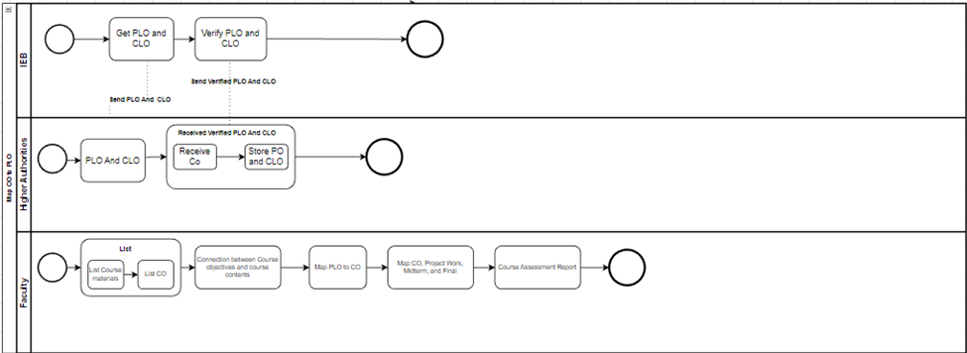Fig 1.1: Map CO To PLO

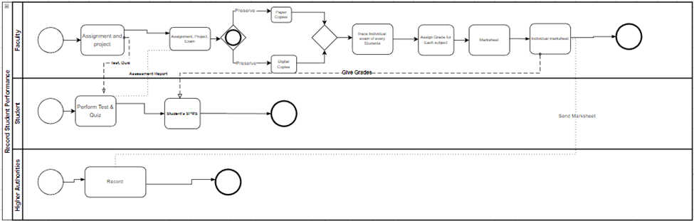Fig 1.2: Record Student Performance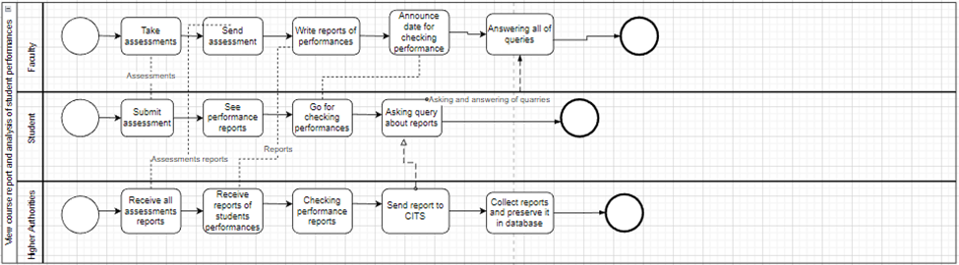Fig 1.3: View course report and analysis of student performances

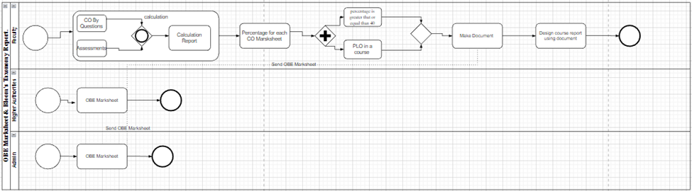fig 1.4: Produce OBE Marksheet & Bloom’s Taxonomy Report.

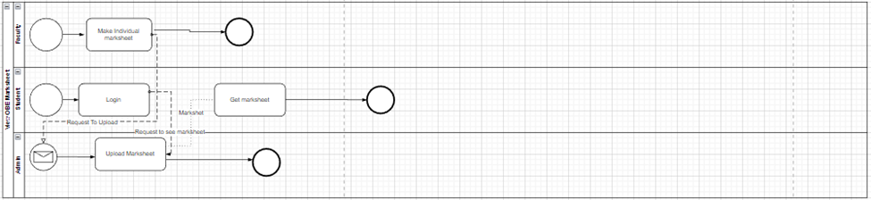Fig 1.5: View Records OBE Marksheets Course.

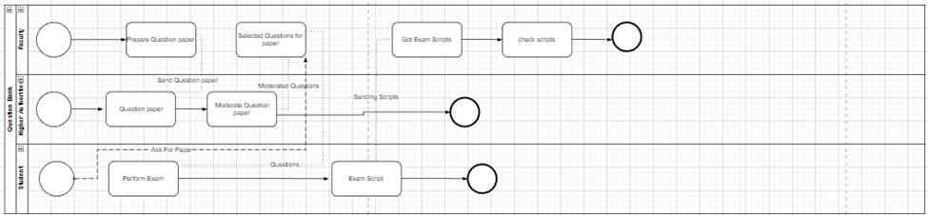Fig 1.6: Request for Question Bank.

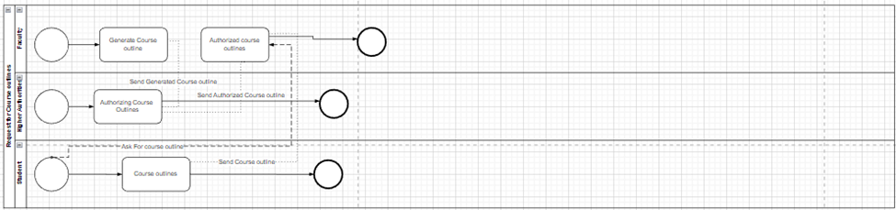Fig 1.7: Request for Course Outline.

**D. PROBLEM ANALYSIS – EXISTING BUSINESS SYSTEM:**

The shortcomings in each process were determined using a Six Elements Analysis of the existing systems. The far-right column of this table displays a recurring pattern. The creation of a private online platform seems to have numerous positive effects on the system.

|  |  |  |  |  |
| --- | --- | --- | --- | --- |
| **Process Name** | **Stakeholder** | **Concerns(Problem)** | **Analysis(Reason of the Problem)** | **Proposed Solution** |
| Update the PLO's initial mapping | 1. Department | The department has to manually map each course under the present system using paper and pen. Therefore, the department must manually prepare the mapping again if updates are necessary. This is a serious problem. | The department must create the mapping manually under the current system, which takes time, adds more labor, and does not make the most use of available resources. | Therefore, the following are the methods to address this issue:  1. A weight or level will be given to each PLO and course.  2. The PLO and Courses are mapped based on this weight/level. The resulting matrix would be used to perform the initial mapping.  3. Depending on how many courses and courses that have PLO, the admin may quickly adjust the mapping. |
| Reviewing scripts and creating grade sheets. | 1. Student  2. Faculty  3. Department | 1. Answer scripts are manually reviewed and marked by specific faculty members.  2. The grade sheets' marks must be manually calculated, tabulated, and graded by the members. | Given the number of students, manually reviewing answer scripts takes a lot of time, and then there's the manual creation of grade sheets. The likelihood of error while checking the scripts rises as a result. | These problems can be resolved through automation:  1. The system will automatically check scripts and provide the mark sheet for exams with multiple-choice questions. If the exam is in quiz format, for example, our system shows the MCQ marks and also provides the answer scripts.  2. For tests of this nature, faculty members must hand check, mark, and grade the answer sheets. However, the system creates the grade sheet after the marks are submitted. The system will provide the grades and marks to the students. |
| Automated mapping to prepare for a particular course preparation for course assessment. | 1. Faculty | It takes time and won't always be consistent for faculty to base their course preparation on the prior PLO or first mapping of the PLO.  They have to keep track of how many PLOs they are mapping when mapping PLO and CO, which can be difficult and cause other issues. | The faculty must manually construct the mappings under the current system, which increases the likelihood of mistakes and issues when they map PLO and CO. | Our system will have predefined PLO labels and course labels to address this issue. If the faculty is happy with the suggested number of CO and assessments, the system will generate a table showing how the CO and assessments are mapped out for them. (They may update the mappings if they are not happy.) |
| When creating the test, make suggestions for questions from the question bank | 1. Faculty members. | Because the faculty must constantly manually map the COs to the questions and construct the question paper, designing questions takes more time and effort. | Because it is not possible to effectively recycle all known prior question papers, the question papers are thrown away after an exam. The professors don't have a binder with former exam papers or an exam history. | All verified question papers will be saved in our system as soft copies that the faculty can access when creating new tests. For instance, it will be advised to look through the exam history of the midterm papers for that course if a faculty is about to create a midterm question paper. In this manner, the time and effort needed to design a paper are both decreased. |
| Generate Continuous Quality Improvement report | 1. Faculty Members  2. SPMS 2.0 Storage | 1. The SPMS is used to gather the progress report.  2. Faculty members must find the lowest percentage for each PLO a student has for all PLOs after personally checking the proportion.  3. Reports must be created from the data. | These activities take time. First, it takes time for the report to be transferred from SPMS to the faculty. Additionally, faculty members are more likely to make mistakes while determining the lowest proportion. The instructor may unintentionally enter some incorrect data when assembling the information. Furthermore, since each semester will be subject to change depending on the students' performance, it is needlessly difficult to pinpoint issues and find solutions. | A Continuous Quality Improvement report with the following information will be produced in our system:  1. A graph showing the number of students enrolled in each department over a given time frame/number of semesters.  2. A course-wise student performance trend for a given time period/semester based on GPA.  3. Student performance trends for a certain time period/semester based on instructors, using GPA.  4. Trend in student performance for a selected subject, according to the instructor, over a given time frame/semester.  5. The lowest percentage of each PLO for each student and the PLO percentage relating to the particular course. Describe potential fixes or ideas for enhancing the kids' performance.  6. A comparison of the proportion of PLO attempts with the percentage of PLOs that were successful |
| Check question difficulties level | 1. Faculty  2. Department  3. Student | With the current system, the department has no scope to check the difficulty level of the exam questions. As a faculty is preparing the course planning, they must know the ques level when they are making it. | In the current system, the department has to come up with a scope to check the difficulty level of the questions. But there is no implemented scope to check this in the SPMS system. | As such, these are the ways to combat this problem:  1. Bloom's Taxonomy feature has to be implemented here.  2. The faculty member must check the question difficulty level while they were making the questions.  3. Also graph displaying the level of the questions by following the keywords of the questions. |

**E. RICH PICTURE - PROPOSED SYSTEM:**

Based on the issues and issues we discovered throughout the problem analysis, we would use several user interfaces created for particular user needs. The report of a student may be viewed by the department head, dean of the school, course instructor, coordinator, faculty, administrative assistant, student, IEB, UGC, ministry of education, vice chancellor, board of trustees, and department staff, among other state parties.

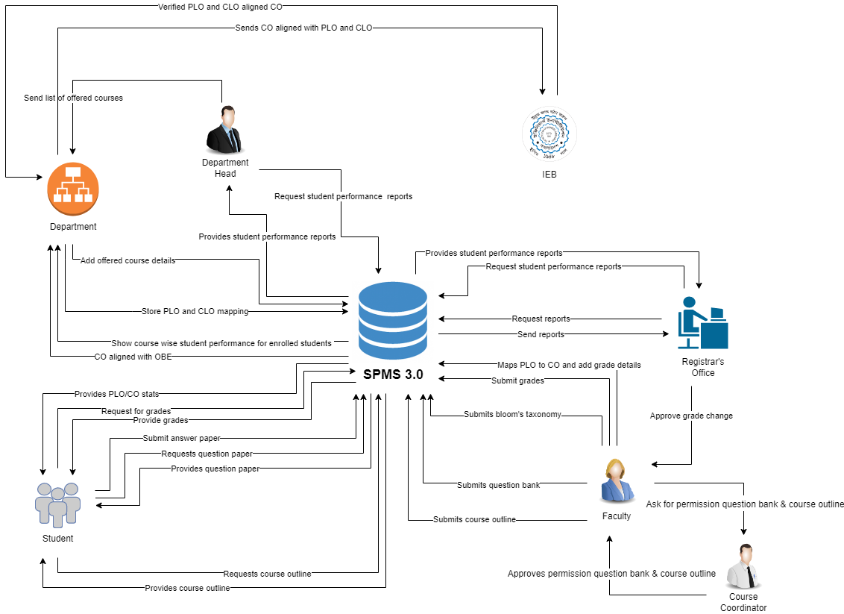

Figure 1.2: Rich Picture of Proposed System to Monitor Student Performance.

**F. SIX ELEMENTS ANALYSIS – PROPOSED SYSTEM :**

The new system, an online platform called SPMS, where it will have its own database that host the data of all the courses, faculties, as well as updated tables every semester to keep track of which courses have been assigned to which faculties in a given semester, will make the Course Outcomes (COs) and Program Learning Outcomes (PLOs) visible. We are developing the new system in order to track student performance as well as faculty members who are instructing a particular course or the performance of students over time in a course.In a nutshell, we can observe that the SPMS relational database (a non-human) quite literally plays a vital role in the student performance monitoring system. Additionally, compared to other other processes, this one has the most connections.

The suggested system's six-element analysis is the next step in a sequence of analysis where each analysis builds on the one before it. The table below provides additional insight into the function of each component of the new system based on the detailed picture.

|  |  |  |  |  |  |  |
| --- | --- | --- | --- | --- | --- | --- |
| **Process** | **System Roles** | | | | | |
|  | **Human** | **Non_computing Hardware** | **Computing Hardware** | **Software** | **Database** | **Network & Communication** |
| **Review and update the Initial Mapping of PLO’s (Course-wise)** | **Department:**  1. Department must enter the system's website to map PLO and CLO aligned with CO.  2. Click on mapping to map and then a new table is generated and shown.  3. The tables contain the lists of all courses and PLOs. It also shows how a PLO can be mapped to various courses as well as how many PLOs can be mapped with a certain course.  4. The PLOs and courses will have labels. The PLOS will be shown based on the level that will help the department to identify PLO mapping.  5. Then the department can store it in our system database through a click. | **Pen & Paper:**  PLOs and the courses are mapped by using pen and paper. | **Computer:**  Computer is used for entering our website and updating the PLO and course mapping. Moreover, the course outline and course details can be viewed. | **SPMS 3.0:**  SPMS 3.0 is required to update PLO and CO mapping.  **Operating system:**  Any operating system can be used by users, Windows, Mac, Linux etc. | **SPMS 3.0 Database (Unsure):**  The mappings of PLOs and COs are stored here. | **Internet:**  It is an online website. It is required to upload the PLO and course planning. |
| **Course Progress** | **Faculty:**  1. The faculty logs in successfully using ID and password.  2. Goes to the question paper creation section.  3. Designates an exam type as well as dictates the total marks.  4. Sets question numbers. | **Pen & Paper:**  Some questions may have to be answered in a paper and scanned for upload. Rough work may be done. | **Computer/ Laptop/ Smartphone:**  Both the students and the faculty need devices to conduct the examination successfully. | **Internet Browser:**  Suitable internet browsers for website navigation such as Google Chrome, Mozilla Firefox, Safari etc. | **SPMS 3.0 Database:**  For storing the information of the faculty and the student users and also question papers, data. | **Internet:**  Used for accessing the SPMS 3.0 software and database by both students and faculty members. |
| **Make grade sheets after checking Answer Script** | **Faculty:**  1. The faculty has to input the answers into the system and check script as well as mark accordingly. For example, the website will show the marks and answers for the MCQs in a quiz.  2. The system composes mark sheets in excel files which the faculty collects.  **Student:**  1. Students can look over their marks and answer scripts directly on the website.  2. They can detect their grade on the website. | **Paper:**  When the faculty has to print the mark sheets and grade sheets, he/she uses paper. | **Computer/ Laptop:**  In the purpose of logging into the website for checking the marks and grades by both the students and faculty members.  **Printer:**  For printing the necessary documents such as mark sheets, grade sheets etc. | **SPMS 3.0:**  Requisite for examining answer scripts, marks and grade sheets. | **SPMS 3.0 Database:**  Requisite for storing answer scripts, marks and grade sheets. | **Internet:**  To access the SPMS 3.0 software and database, it is used by both the students and faculty members. |
| **Mapping a specific course automatically and prepare the course assessment Planning** | **Faculty:**  1. The initial mapping of PLO and course is already done by the department. Faculty members have to enter the website first and then log in with their IDs.  2. They can view their assigned course and the PLOs for that course that are suggested by the department.  3. If a report is available, the faculty can view the CQI report. If it is necessary then the faculty members can also update the PLO mapping.  4 System will provide the faculty with a few suggestions. For example, the number of course outcomes and PLO with the label wise courses, the specific PLOs, the number of assessments etc. If the faculty members want to change something then they have to select the number of CO and map that CO with PLO.  5. Designs a specific question in an alike pattern by browsing through the previous papers of the almost identical types of exam.  6. Set out the marking for that question.  7. If it is needed then make another question by using the same procedures 4-6.  8. Clicks on the "Save" option and successfully saves the paper as usual.  9. In addition, include further information regarding the exam. For instance, the duration topics etc.  **Student:**  1. The student logs into the website by successfully using ID and password.  2. Clicks on the exam section for the exam history and the upcoming exam announcements for all courses the student is enrolled in during the registration of that ongoing semester.  3. They can learn about details of other exams and the syllabus by clicking upcoming exams options. | **Stationary:**  Paper is used for printing the necessary instructions for the course outline and assessments planning as CO and PLO based details.  Necessary tools such as calculator, ruler, pencil, eraser etc. are needed for solving all questions and writing them. | **Computer:**  For logging into our website and adopting the PLO and CO mapping assessment planning and mapping. By using a computer or laptop, the course CQI report and course can also be viewed. If there is something to be changed based on the COI report then the changes will be made by using a computer. | **SPMS 3.0:**  SPMS 3.0 is needed for updating the PLO and CO mapping, assessment and course outcome mapping etc.  **Operating System:**  The user may use any OS such as Windows, Mac, Linux etc. | **SPMS 3.0 Database:**  The mappings of PLOs and COs are reserved here. | **Internet:**  The internet is required to update the PLO and CO mapping and also the assessment planning. |
| **Update student enrollment information in SPMS** | **Registrar Office:**  1. SPMS 3.0 gives the notice of updating the student information to the registrar office.  2. The updated enrollment report for the student is submitted.    **Higher Authority (Imperium):**  1. Requests to access the student enrollment report.  2. View the student enrollment report in the form of a graph. | **Paper:**  Used for printing necessary documents.    **Pen:**  Used for writing something on the report. | **Computer:**  Used for logging to the website and conducting respective tasks by higher authority and registrar office members.    **Database Server:**  Receiving data from the registrar office as well as sending data to them in order to store or update information into the database. | **SPMS 3.0:**  Used for updating the student enrollment information.    **Operating System:**    The user may use any OS such as Windows, Mar, Linux etc. | **SPMS 3.0 Database:**  The updated student enrollment information is stored here. | **Internet:**  To access the SPMS 3.0 software and the database, the registrar office personnel and higher authority use the internet. |
| **Generate CQI Report** | **Faculty:**  1. Launch the website first.  2. Find and select the desired course.  3. The system will present all activities upon clicking the student performance option.  4. The CQI report button will display PLO percentage upon click.  5. Check if a student falls below a certain PLO (soft copy) on that exam section.  6. Give feedback via rating on that specific exam. | **Paper:**  When a faculty wants to print any types of documents then the paper is being used. | **Computer:**  Computer is used by both the students and faculty members to log into the website and generate the report.    **Database Server:**  The faculty has access to the database where they can store or update the information into the database. | **SPMS 3.0:**  The report has originated through the system.    **Operating System:**    The user may use any OS such as Windows, Mac, Linux etc. | **SPMS 3.0 Database:**  The database is used for the purpose of storing the updated report. | **Internet:**  Used by the faculty members to access the SPMS 3.0 software and database. |

**G. PROCESS MODEL - PROPOSED SYSTEM:**

The Business Process Model and Notation provide an unambiguous description of the precise order of steps that will be taken to complete each process after understanding the role of each element in each process. Each module in this diagram will act as the high-level foundation from which the implementation specifics in the following chapter will be derived.

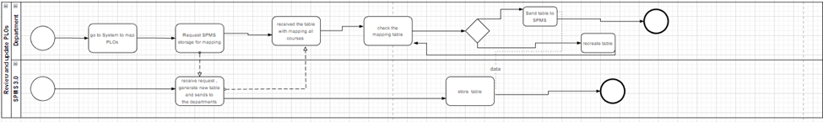Fig 1.8: Review and update PLOs

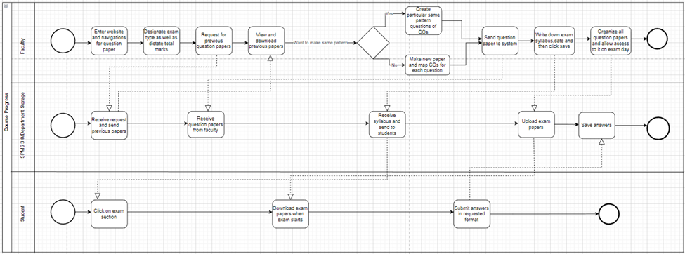Fig 1.9: Course Progress

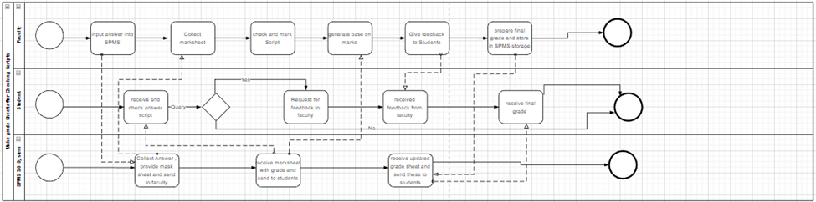Fig 1.10: Make grade Sheet after Checking Scripts

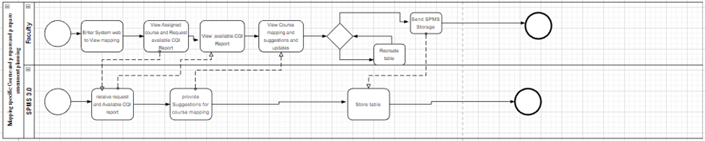Fig 1.11: Mapping specific Course and prepare and prepare assessment planning

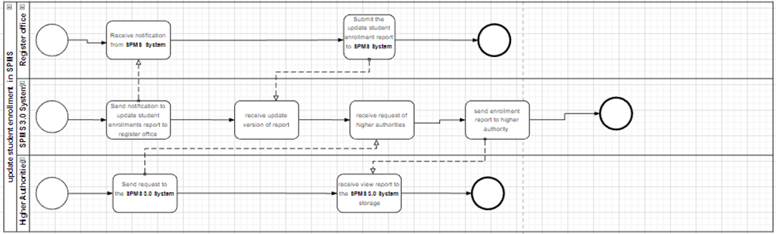Fig 1.12: update student enrollment in SPMS

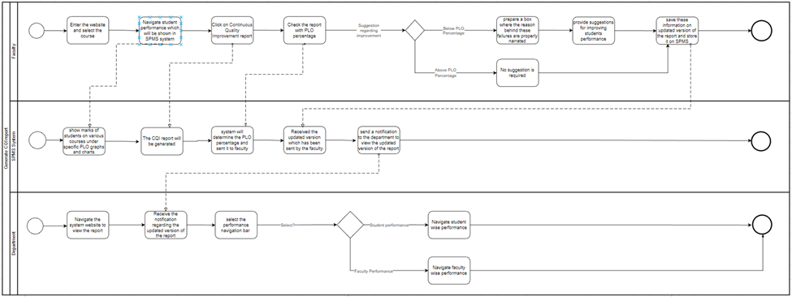Fig 1.13: Generate CQI report

**CHAPTER 3 - LOGICAL SYSTEM DESIGN:**

In this chapter, we'll go through the steps of building a data model for our hypothetical system so that the data may be stored in a database. The links between various data objects, the rules, and the conceptual representation of the data objects are all included in this data model. Data modeling supports the visual representation of data and applies corporate policies, legal requirements, and governmental directives to the data. The consistency of naming conventions, default values, semantics, and security are all ensured by data models, which also guarantee the accuracy of the data. For a better representation of all the data, we will be constructing our suggested system.

**A. BUSINESS RULE [ SPMS 3.0]:**

Business rules outline the procedures, concepts, and limitations that control the data model. They are written in standard English sentences as opposed to the ERD so that a stakeholder who is not technically inclined can understand information about the data model without being aware of notational conventions. Our data model is governed by the following business rules:

1. A student must have one department. A STUDENT has StudentID, FirstName, LastName, DateofBirth, Gender, Email, Phone, Address, EnrollmentDate. A department must have many students.

2. A section mandatorily has many students. A student may enroll in many sections. A section includes SectionID, SectionNum, CourseID, FEmployeeID, Semester, Year.

3. Students may complete many evaluations. An EVALUATION includes EvaluationID, ObtainedMarks, StudentID, CourseID, QuestionID. An evaluation must be performed by at least one student.

4. An evaluation must have one Question. A Question must have many evaluations. Question assigns QuestionID, ExamType, TotalMarks, QuestionContent, Bloom’sTaxonomyLevel, FEmployeeID, COID. A question must create one faculty. A faculty creates many questions.

5. A CO’s must map with one PLO’s. A PLO’s must map with one or many CO’s. PLO includes PLOID, PLONum, Details, ProgramID.

6. A PLO must contain one program. A program contains one or many PLO’s. A program has ProgramID, ProgramName, DepartmentID. A program must contain one or many courses. A Course must contain one program.

7. A program must belong to one department. A department must belong to one or many programs. A department contains DepartmentID, DepartmentName, SchoolID.

8. A department must contain one school. A School must contain one or many departments. A school includes SchoolID, SchoolName.

9. An employee has three sub-type( Dean, Department Head, Faculty). An employee includes EmployeeID, FirstName, LastName, Email, Address, EmployeeType.

10. A school must be run by one or many Dean. A dean must run one school. A Dean has SchoolID, StartDate, EndDate.

11. A Department must manage one or many Department head. A department head must manage one department. A department head includes DepartmentID, StartDate, EndDate.

12. A Faculty must have one Department. A department must have one or many Faculties. A Faculty includes FEmployeeID, DepartmentID,COutlineID, Rank, JoinDate, ConsultantHour. A faculty may teach many sections. A section must be taught by one faculty.

13. A question must map with one CO’s. A CO’s maps with one or many questions. A CO’s includes CONum, COID, CourseID, PLOID. And questions include QuestionNum,ExamType,TotalMarks,Bloom’sTaxonomyCategory, Bloom’sTaxonomyLevel. A CO must contain one Course. A Course contains one or many CO’s.

14. A course may have many prerequisites. A course includes CourseID, CourseName, CourseType, CreditValues, ProgramID, COutlineID. A course must contain one course outline. A course outline may be one course.

15. A course outline must affiliate one mark distribution. A mark distribution may affiliate many courses. A course outline includes MarkDistribution. Mark distribution represents multi valued course assessment and percentage exam type wise( quiz, midterm, final, project) and CoursePolicy. Faculty must prepare one course outline. A course outline may prepare one faculty.

**B. ENTITY RELATIONSHIP DIAGRAM:**

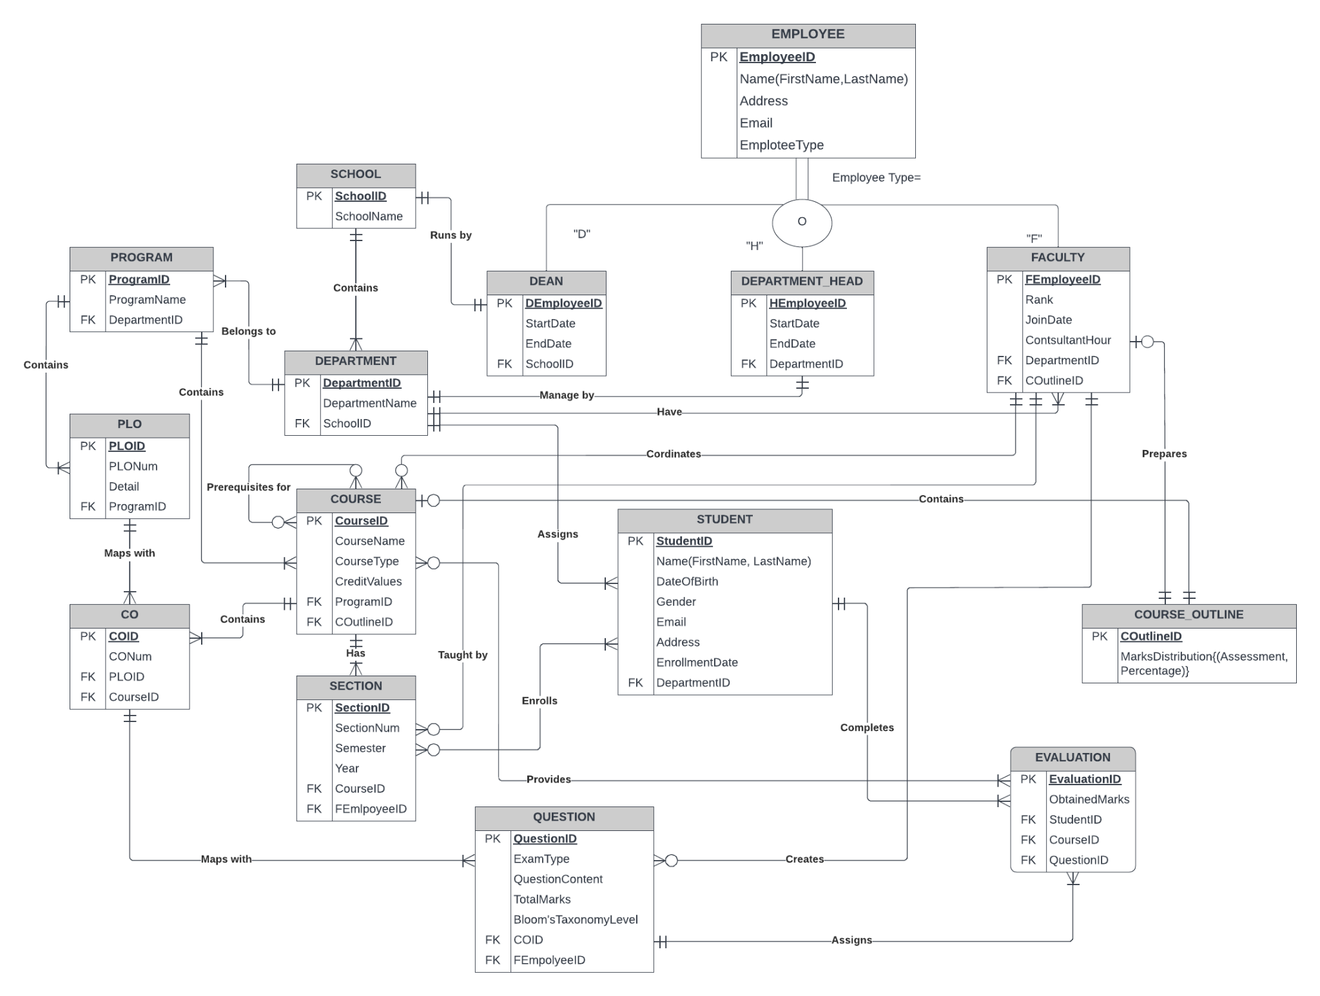

Figure 3.1: Entity relationship diagram

**C. ENTITY RELATIONSHIP DIAGRAM TO RELATIONAL SCHEMA:**

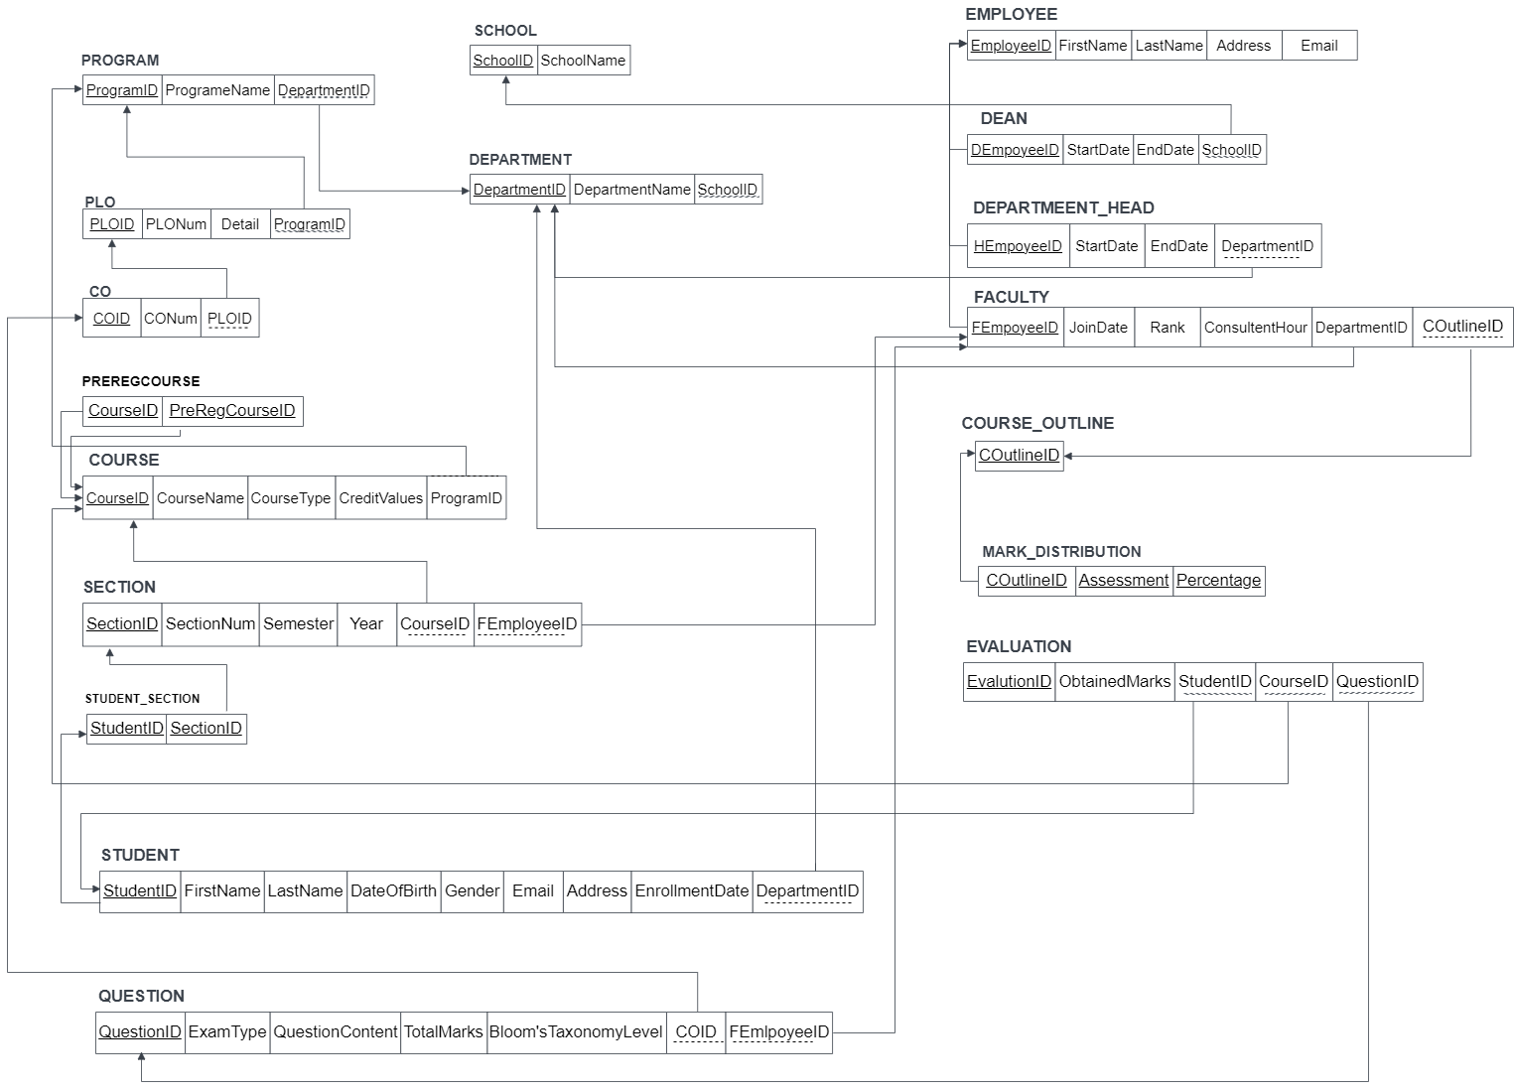

Figure 3.2: Entity relationship diagram

**D. NORMALIZATION:**

|  |  |
| --- | --- |
| SchoolID  L1 | SchoolName  L2 |
| DepartmentID  D1 | DepartmentName, SchoolID  D2, L1 |
| ProgramID  P1 | ProgramName, DepartmentID  P2, D1 |
| PLOID  A1 | PLONum, Detail, ProgramID  A2, A3, P1 |
| COID  B1 | CONum, PLOID  B2, A1 |
| CourseID  R1 | PreRegCourseID  R2 |
| CourseID  C1 | CourseName, CourseType, CreditValues, ProgramID  C2, C3, C4, P1 |
| SectionID  G1 | SectionNum, Semester, Year, CourseID, FEmployeeID  G2, G3, G4, C1, F1 |
| StudentID  N1 | SectionID  G1 |
| StudentID  S1 | Firstname, LastName, DateOfBirth, Gender, Email, address, EnrollmentDate, DepartmentID  S2, S3, S4, S5, S6, S7, S8, D1 |
| QuestionID  Q1 | ExamType, QuestionContent, TotalMarks, Bloom’sTaxonomyCategory, Bloom’sTaxonomyLevel, COID, FEmployeeID  Q2, Q3, Q4, Q5, Q6, B1, F1 |
| EmployeeID  E1 | FirstName, LastName, Address, Email  E2, E3, E4, E5 |
| DEmployeeID  I1 | StartDate, EndDate, SchoolID  I2, I3, L1 |
| HEmployeeID  H1 | StartDate, EndDate, DepartmentID  H2, H3, D1 |
| FEmployeeID  F1 | Join date, Rank, ConsultentHour, DepartmentID, COutlineID  F2, F3, F4, D1, J1 |
| COutlineID  J1 | CoursePolicy  J2 |
| COutlineID  K1 | Assessment, Percentage  K2, K3 |
| EvalutionID  M1 | ObtainedMarks, StudentID, CourseID, QuestionID  M2, S1, C1, Q1 |

L1 -> L2

D1 -> D2, L1

P1 -> P2, D1

A1 -> A2, A3, P1

B1 -> B2, B3, A1

R1 -> R2

C1 -> C2, C3, C4, P1

G1 -> G2, G3, G4, C1, F1

N1 -> G1

S1 -> S2, S3, S4, S5, S6, S7, D1

Q1 -> Q2, Q3, Q4, Q5, Q6, B1, F1

E1 -> E2, E3, E4, E5

I1 -> I2, I3, L1

H1 -> H2, H3, D1

F1 -> F2, F3, F4, D1

J1 -> J2

K1 -> K2, K3

M1 -> M2, S1, C1, Q1

**1NF:** A relation that has a primary key and in which there are no repeating groups.

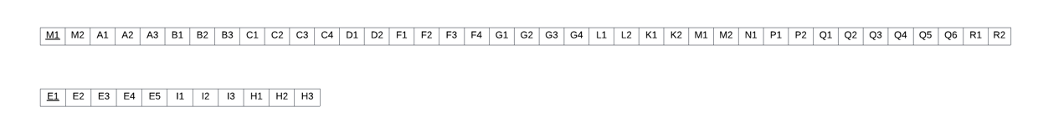

Figure 3.3: 1NF

**2NF:** A relation in the first normal form in which every non-key attribute is fully functionally dependent on the primary key.

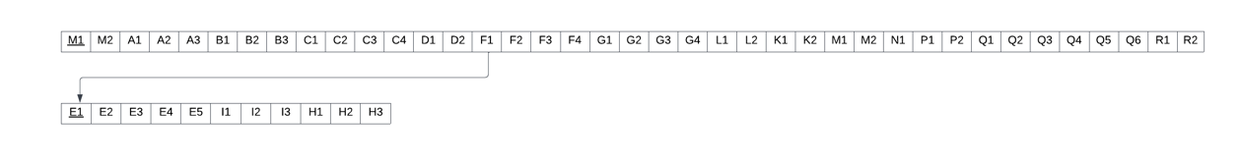

Figure 3.4: 2NF

**3NF:** A relation that is in second normal form and has no transitive dependencies.

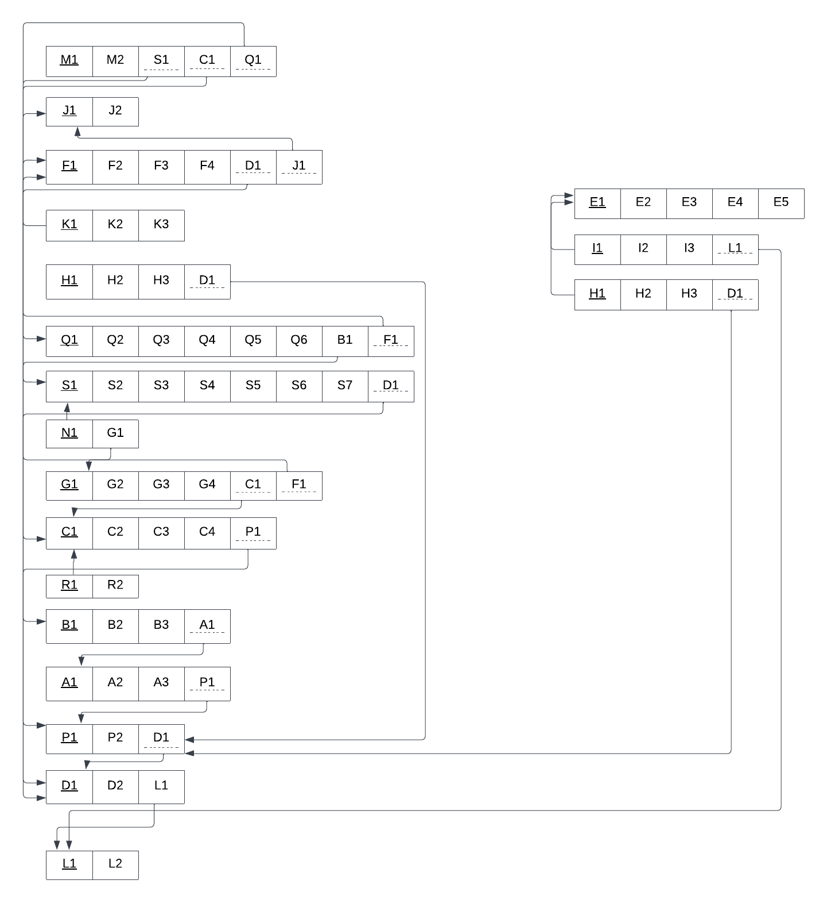

Figure 3.5: 3NF

**BCNF:** All determinants are candidate keys. There is no determinant that is not a unique identifier. Here, all the relations already are in BCNF.

**E. DATA DICTIONARY:**

School_T

|  |  |  |  |
| --- | --- | --- | --- |
| Name | Data Type | Size | Remarks |
| SchoolID | VARCHAR | 5 | This is the primary key of School.  E.g: “SETS’’ or “SLASS” |
| SchoolName | VARCHAR | 45 | This is the name of the School.  E.g: “School of Engineering, Technology  & Science”. |

Program_T

|  |  |  |  |
| --- | --- | --- | --- |
| Name | Data Type | Size | Remarks |
| ProgramID | INTEGER |  | This is the primary key for a program.  E.g: “1” |
| ProgramName | VARCHAR | 30 | This is the name of the program.  E.g: “Bachelor of Science” |
| DepartmentID | VARCHAR | 4 | This is the foreign key from the  Department table.  E.g: “CSE” or “BBA’’ |

Department_T

|  |  |  |  |
| --- | --- | --- | --- |
| Name | Data Type | Size | Remarks |
| DepartmentID | VARCHAR | 5 | This is the primary key for the  Department table.  E.g: “CSE” |
| DepartmentName | VARCHAR | 45 | This is the name of the department.  E.g: “Computer Science and Engineering”. |
| SchoolID | VARCHAR | 5 | This is a foreign key from the School  table.  E.g: “SETS”or “SLASS’’. |

Student_T

|  |  |  |  |
| --- | --- | --- | --- |
| Name | Data Type | Size | Remarks |
| StudentID | INTEGER |  | This is the primary key for the Student  table.  E.g: “1830707”. |
| FirstName | VARCHAR | 20 | This is the first name of the student.  E.g: “Md Akram”. |
| LastName | VARCHAR | 20 | This is the last name of the student.  E.g: “Hossain”. |
| DateOfBirth | DATE | DD-  MM-  YYYY | This is the birth date of the student.  E.g: “31-12-1998”. |
| Gender | VARCHAR | 6 | This is the gender of the student.  E.g: “Male”. |
| Email | VARCHAR | 30 | This is the email of the student.  E.g: “1830707@iub.edu.bd” |
| Phone | NUMERIC | 11 | This is the phone of the student.  E.g: “01XXXXXXXXX”. |
| Address | VARCHAR | 50 | This is the address of the student.  E.g: “House 238,Road 8,Tejgaon,Dhaka |
| DepartmentID | VARCHAR | 5 | This is the foreign key from the  Department table.  E.g: “CSE” |
| ProgramID | INTEGER |  | This is the foreign key from the Program  table.  E.g: “1” |
| EnrollmentDate | DATE | dd-mm-yyyy | This is the enrollment date of the student.  E.g.: “1-1-2018” |

CO_T

|  |  |  |  |
| --- | --- | --- | --- |
| Name | Data Type | Size | Remarks |
| COID | VARCHAR | 5 | This is the primary key for the CO table.  E.g: “CO1”. |
| CONum | INTEGER |  | This is the CO number.  E.g: 1,2 etc. |
| CourseID | VARCHAR | 8 | This is the foreign key from the Course table.  E.g: “CSE303” |
| PLOID | VARCHAR | 5 | This is the foreign key from the PLO table.  E.g: “PLO1” |

PLO_T

|  |  |  |  |
| --- | --- | --- | --- |
| Name | Data Type | Size | Remarks |
| PLOID | VARCHAR | 5 | This is the primary key for Program Learning  Outcome.  E.g: “PLO1” |
| PLONum | INTEGER |  | This is the PLO number. E.g: “1” |
| Details | VARCHAR | 50 | This is the details for Program Learning Outcome.  E.g: “An ability to select and apply the knowledge,  technique, skills and modern tools of the  computer science and engineering discipline ” |
| ProgramID | INTEGER |  | This is a foreign key from the Program table.  E.g: “1” |

Employee_T

|  |  |  |  |
| --- | --- | --- | --- |
| Name | Date Type | Size | Remarks |
| EmployeeID | INTEGER |  | This is the primary key for Employee  table.  E.g: “1001” |
| FirstName | VARCHAR | 20 | This is the first name of the faculty.  E.g: “Sadita” |
| LastName | VARCHAR | 20 | This is the last name of the faculty.  E.g: “Ahmed” |
| Email | VARCHAR | 30 | This is the email address of the  Student.  E.g: “1675231@iub.edu.bd” |
| Address | VARCHAR | 30 | This is the address of the Faculty.  E.g: “House 14, Road 21, Sector  11,Baridara,Dhaka, Bangladesh” |
| EmployeeType | CHAR | 1 | This is the type of the employee.  E.g: “F” |

Course_T

|  |  |  |  |
| --- | --- | --- | --- |
| Name | Data Type | Size | Remarks |
| CourseID | VARCHAR | 8 | This is the Primary Key for the Course.  E.g: “CSE203” |
| CourseName | VARCHAR |  | This is the name of the Course.  E.g: “Database Management System” |
| CreditValues | INTEGER |  | This is the number of credits for the  Course.  E.g: “3” |
| CourseType | VARCHAR |  | This is the type of the Course. E.g: “Core” |
| ProgramID | INTEGER |  | This is the foreign key from the program  table.  E.g: “1” |
| COutlinID | INTEGER |  | This is the Foreign Key from Course  table. |

Section_T

|  |  |  |  |
| --- | --- | --- | --- |
| Name | Data Type | Size | Remarks |
| SectionID | INTEGER |  | This is the Primary Key for Section.  E.g: “1” |
| SectionNum | INTEGER |  | This is the section number.  E.g: “1” |
| CourseID | VARCHAR | 8 | This is the foreign key from the Course  table.  E.g: “CSE101” |
| FEmployeeID | NUMERIC | 4 | This is the foreign key from the Faculty table.  E.g: “1001” |
| Semester | VARCHAR | 6 | This is the semester of the section.  E.g: “Summer” |

Question_T

|  |  |  |  |
| --- | --- | --- | --- |
| Name | Data Type | Size | Remarks |
| QuestionID | INTEGER |  | This is the Primary Key for  Question. |
| ExamType | VARCHAR | 10 | This is the name of the question.  E.g: “Midterm” |
| TotalMarks | NUMBER |  | This is the total marks of the  question.  E.g: “30” |
| BloomsTaxonomyCategory | VARCHAR | 10 | This is the category of the  question.  E.g: “Creating” |
| BloomsTaxonomyLevel | VARCHAR | 10 | This is the difficulty of the  question.  E.g: “Midium” |
| COID | INTEGER |  | This is the Foreign Key from the  Course Outcome table. |
| QuestionContent | INTEGER |  | This is the question number for  question.  E.g: “1,2,3....” |
| SectionID | INTEGER |  | This is the Foreign Key from Section  table. |
| FEmployeeID |  |  | This is the Foreign Key from Faculty  table. |

Evalution_T

|  |  |  |  |
| --- | --- | --- | --- |
| Name | Data Type | Size | Remarks |
| EvaluationID | INTEGER |  | This is the Primary Key for Enrollment. |
| ObtainedMarks | DECIMAL | 5,2 | This is the obtained marks of the student.  E.g: “24.5” |
| QuestionID | INTEGER |  | This is the foreign key from the  Question table. |
| CourseID | VARCHAR | 8 | This is the foreign key from the Course  table.  E.g: “CSE101” |
| StudentID | INTEGER |  | This is the foreign key from the  Student table. |

Dean_T

|  |  |  |  |
| --- | --- | --- | --- |
| Name | Data Type | Size | Remarks |
| DEmployeeID | INTEGER |  | This is the foreign key from the  Employee table.  E.g: “4250” |
| SchoolID | VARCHAR | 5 | This is the SchoolID of the school  DEAN manages.  E.g: “SETS” |
| StartDate | DATE | dd-mm-  yyyy | This is the starting date.  E.g: “01-03-2020” |
| EndDate | DATE | dd-mm-  yyyy | This is the date DEAN retire from his  post. E.g: “01-03-2024” |

DepartmentHead_T

|  |  |  |  |
| --- | --- | --- | --- |
| Name | Data Type | Size | Remarks |
| HEmployeeID | INTEGER |  | This is the foreign key from the  Employee table.  E.g: “4250” |
| DepartmentID | VARCHAR | 5 | This is the DepartmentID of the  department HEAD manages.  E.g: “CSE” |
| StartDate | DATE | dd-mm-  yyyy | This is the starting date.  E.g: “01-03-2020” |
| EndDate | DATE | dd-mm-  yyyy | This is the date HEAD retire from his  post. E.g: “01-03-2024” |

Faculty_T

|  |  |  |  |
| --- | --- | --- | --- |
| Name | Data Type | Size | Remarks |
| FEmoployeeID | INTEGER |  | This is the foreign key from the  Employee table.  E.g: “4250” |
| DepartmentID | VARCHAR | 5 | This is the DepartmentID of the  department faculty belongs to.  E.g: “CSE” |
| JoinDate | DATE | dd-mm-  yyyy | This is the starting date.  E.g: “01-03-2020” |
| Rank | VARCHAR | 20 | This is the rank of the faculty.  E.g: “Assistant Professor” |
| COutlineID | INTEGER |  | This is the Foreign Key from Course Outline  table. |

PreReqCourse_T

|  |  |  |  |
| --- | --- | --- | --- |
| Name | Data Type | Size | Remarks |
| CourseID | VARCHAR | 8 | This is the foreign key from the Course  table. E.g: “CSE303” |
| PreReqCourseID | VARCHAR | 8 | This is the foreign key from the Course  table .  E.g: CSE203 |

CourseOutline_T

|  |  |  |  |
| --- | --- | --- | --- |
| Name | Data Type | Size | Remarks |
| COutlineID | INTEGER |  | This is the primary key from the Course  Outline table. E.g: “1233” |
| MarkDistribution | VARCHAR | 15 | This is the percentage range for  assessment.  E.g: “Project- 50%, Assessment-50%”. |

**CHAPTER 4 - PHYSICAL SYSTEM DESIGN:**

**A. INPUT FORM:**

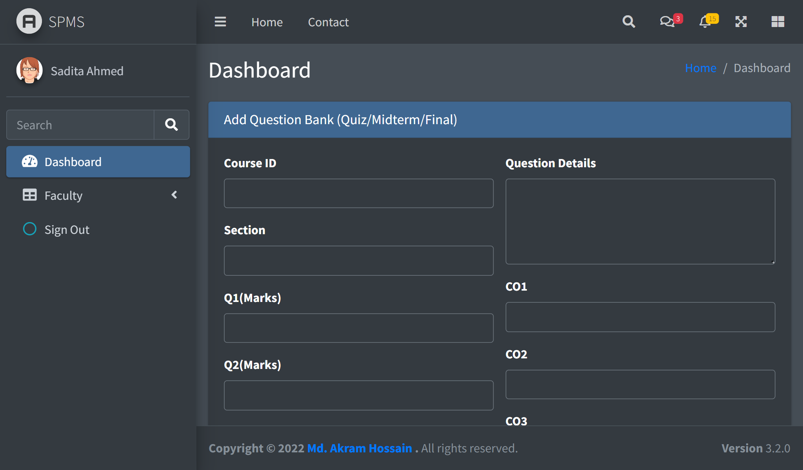

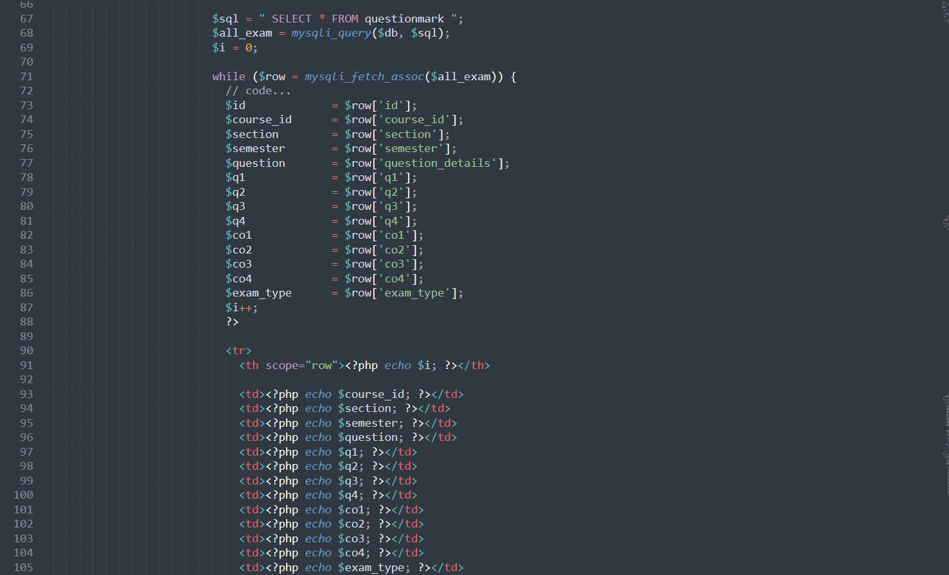

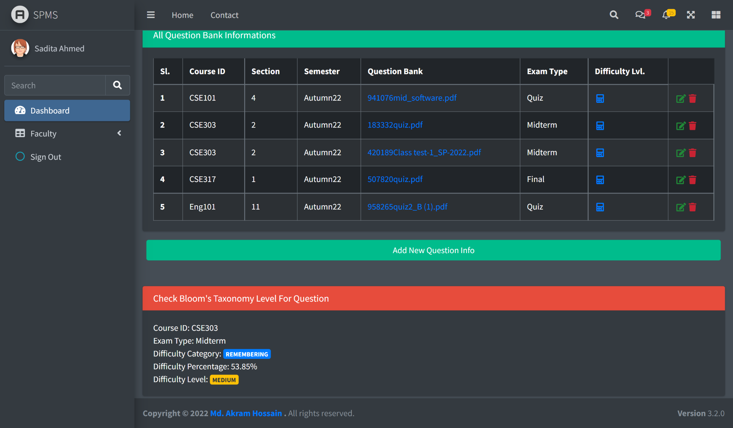

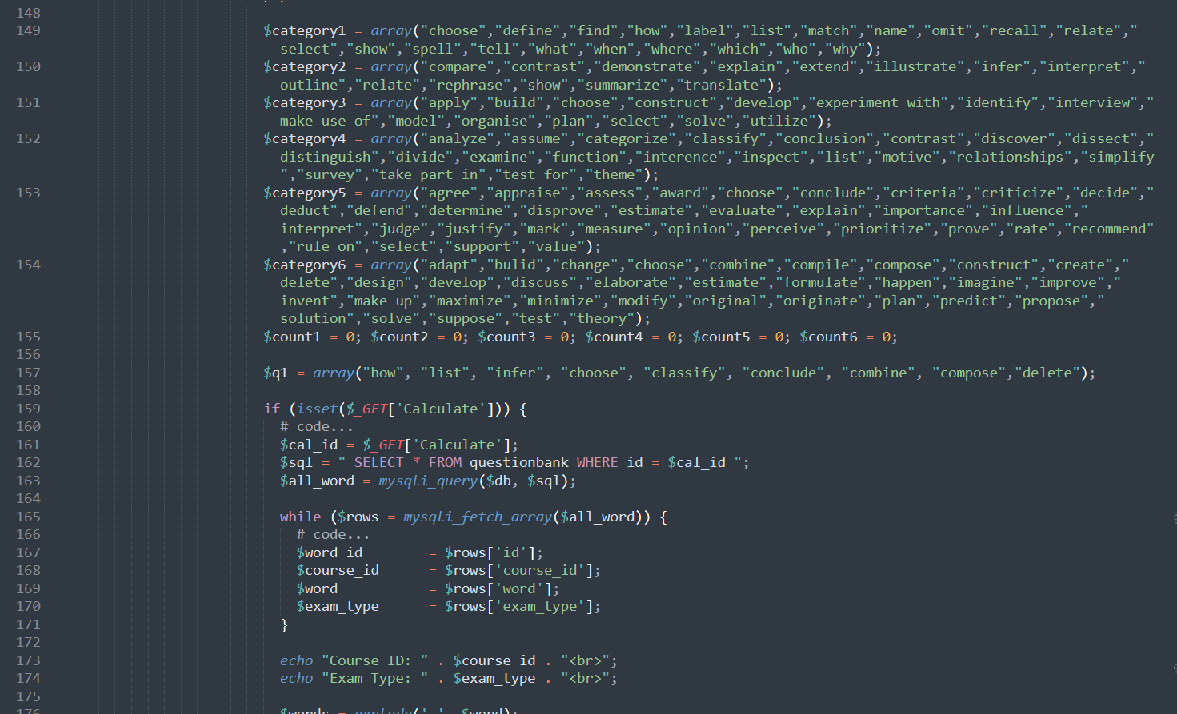

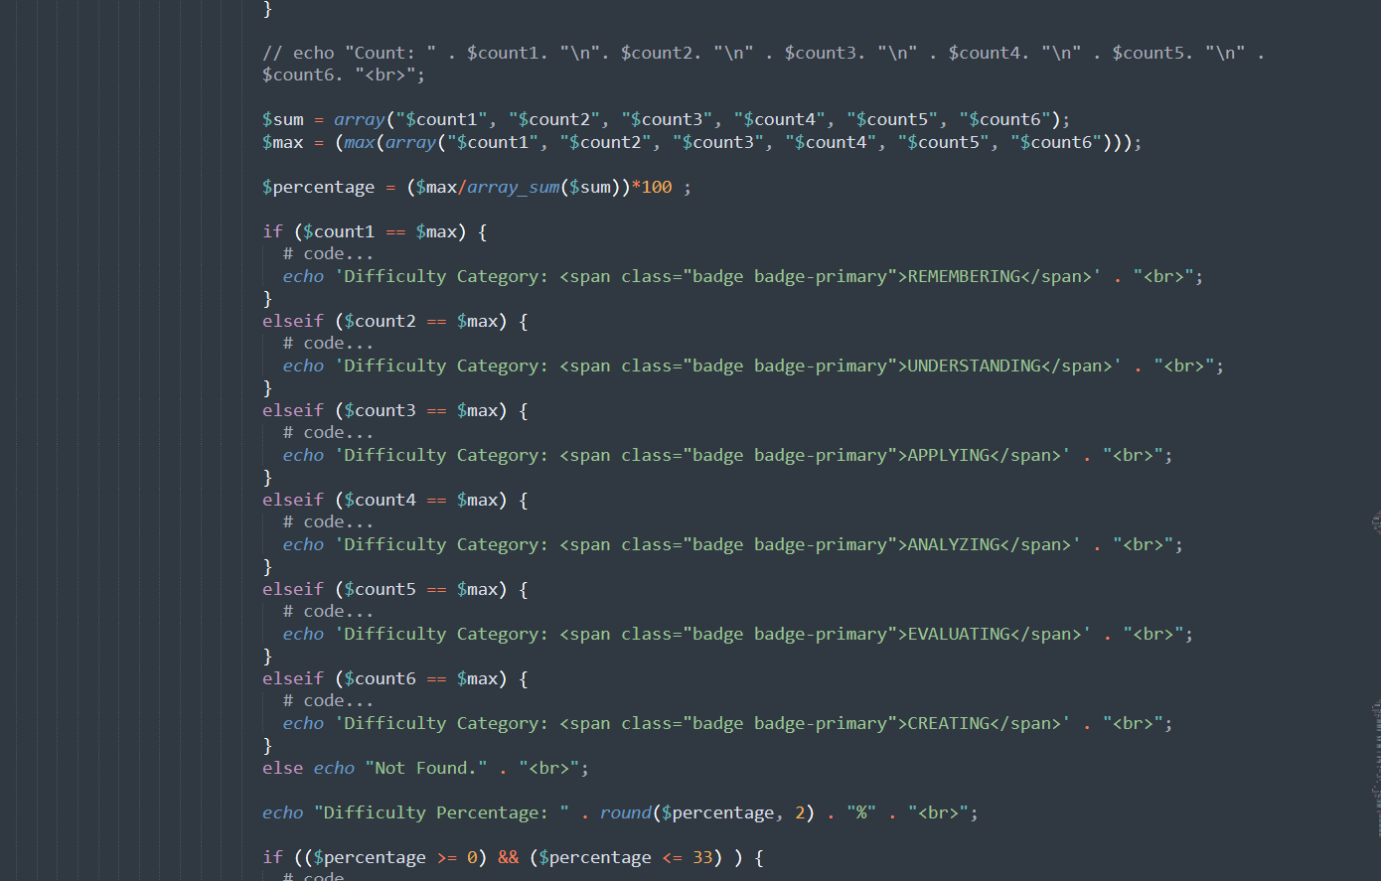

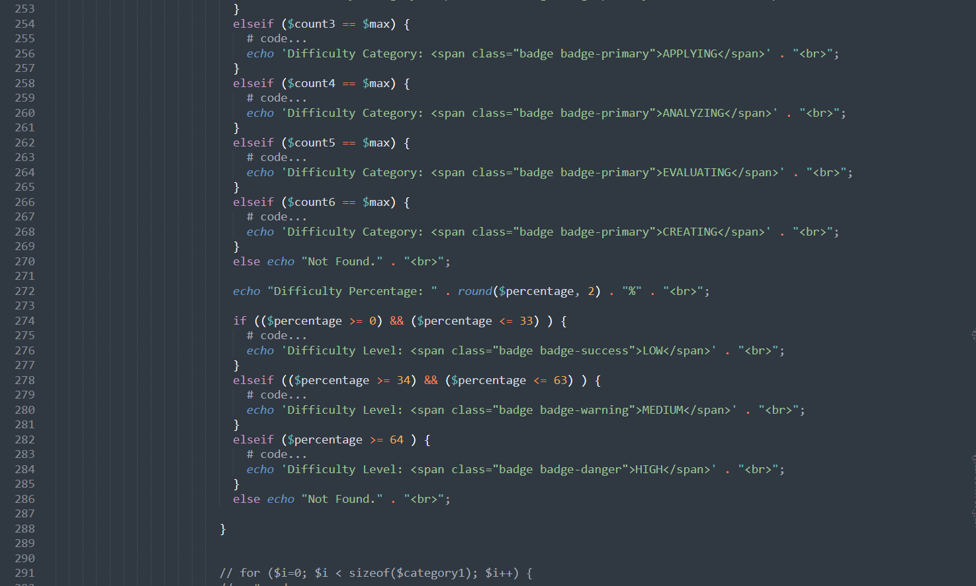

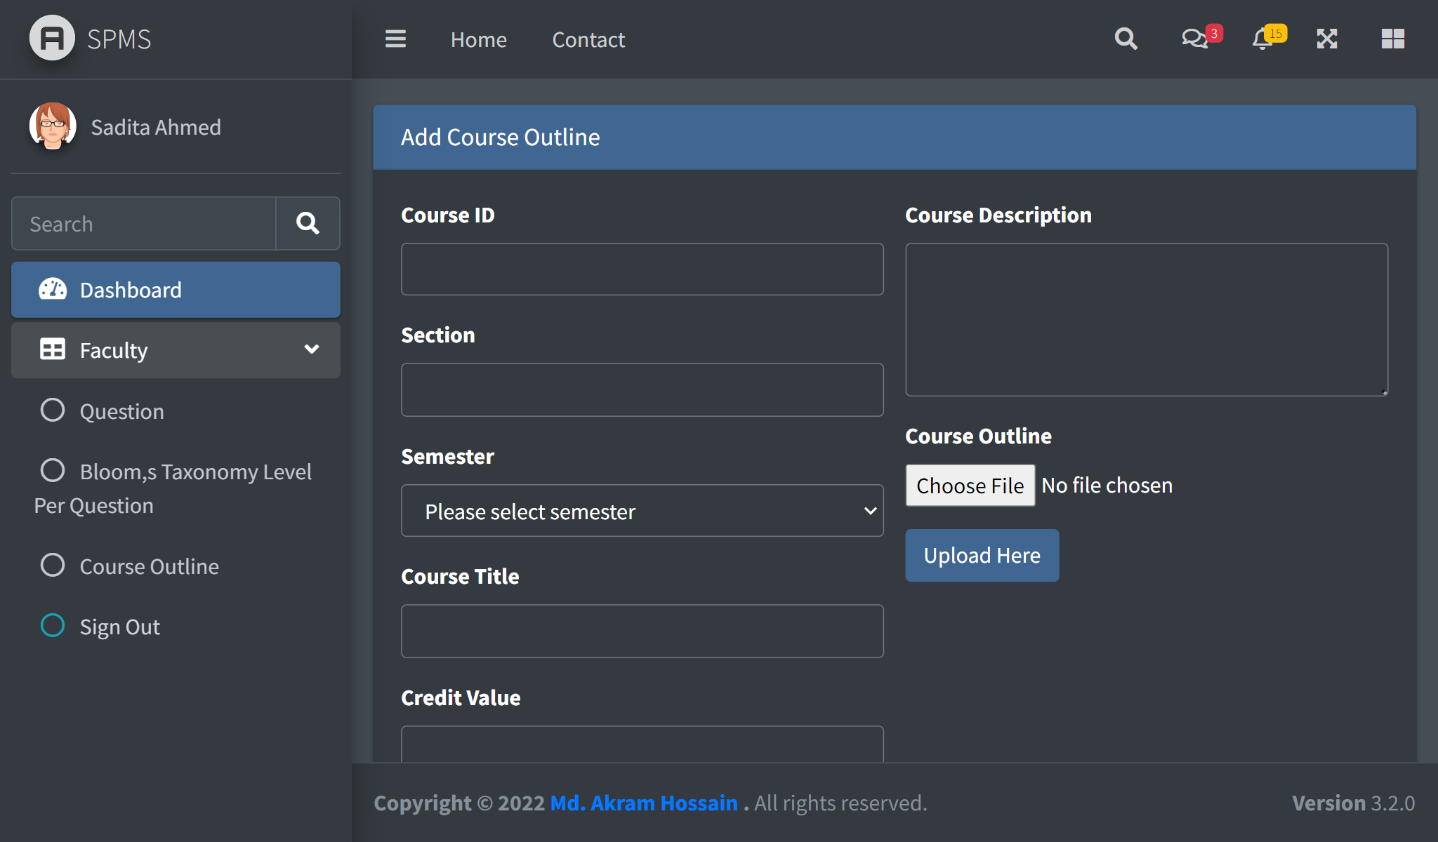

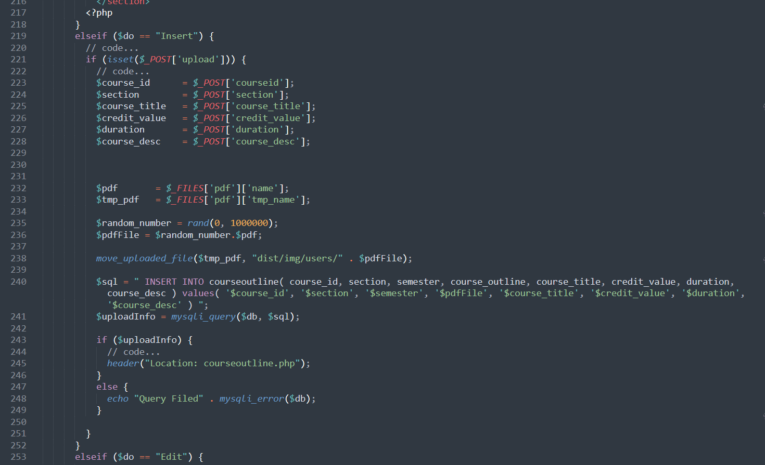

**B. OUTPUT FORMS:**

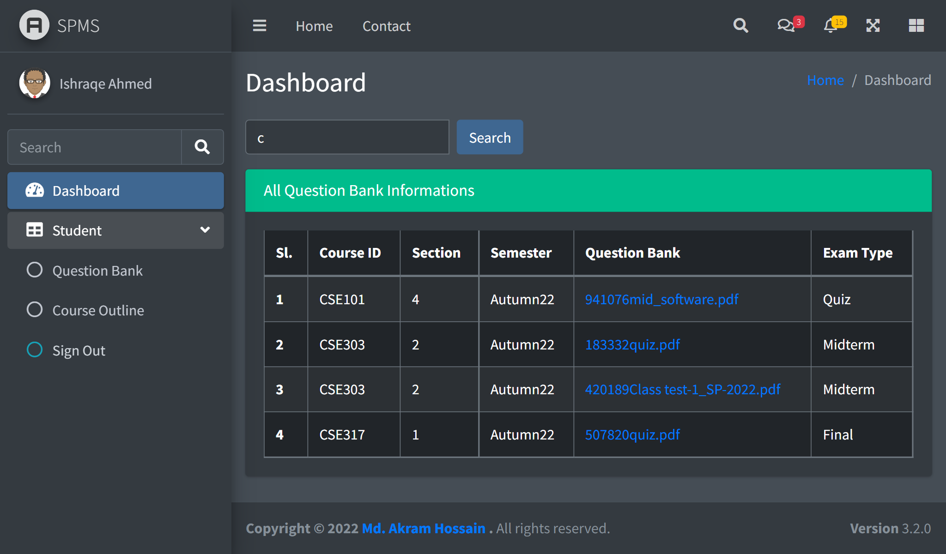

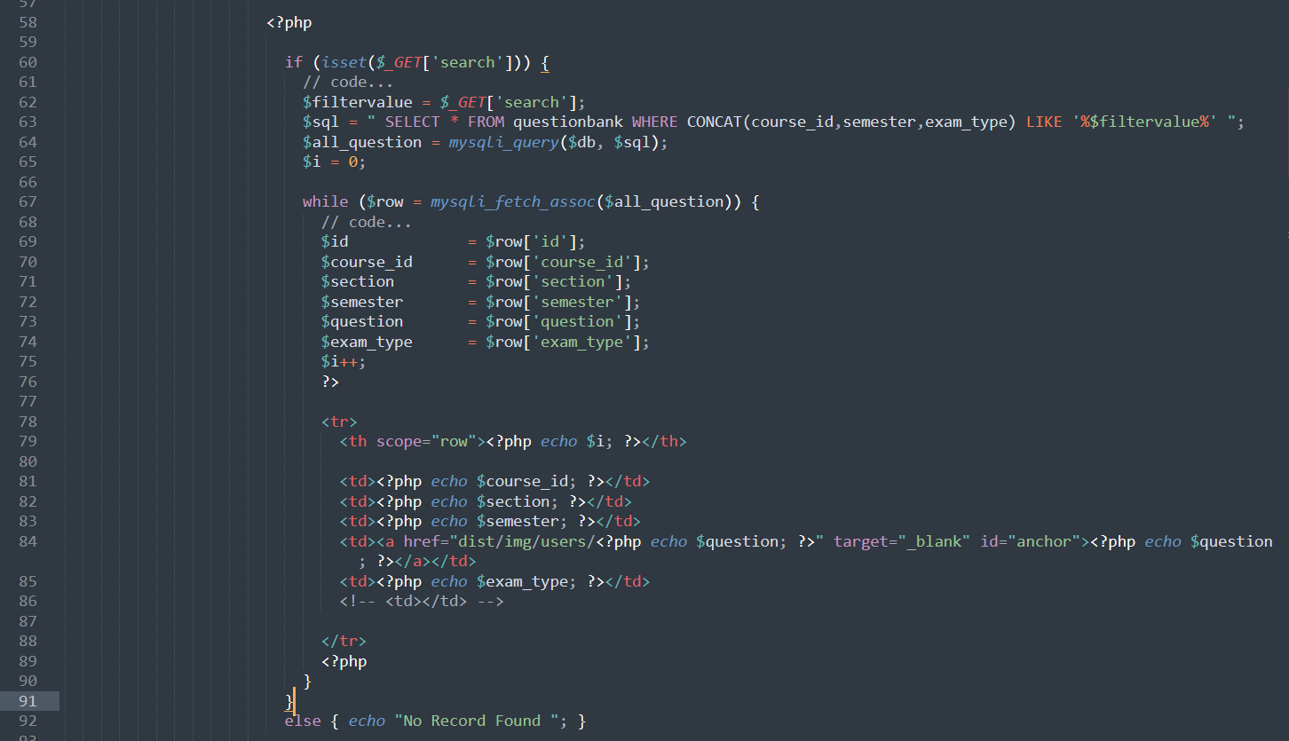

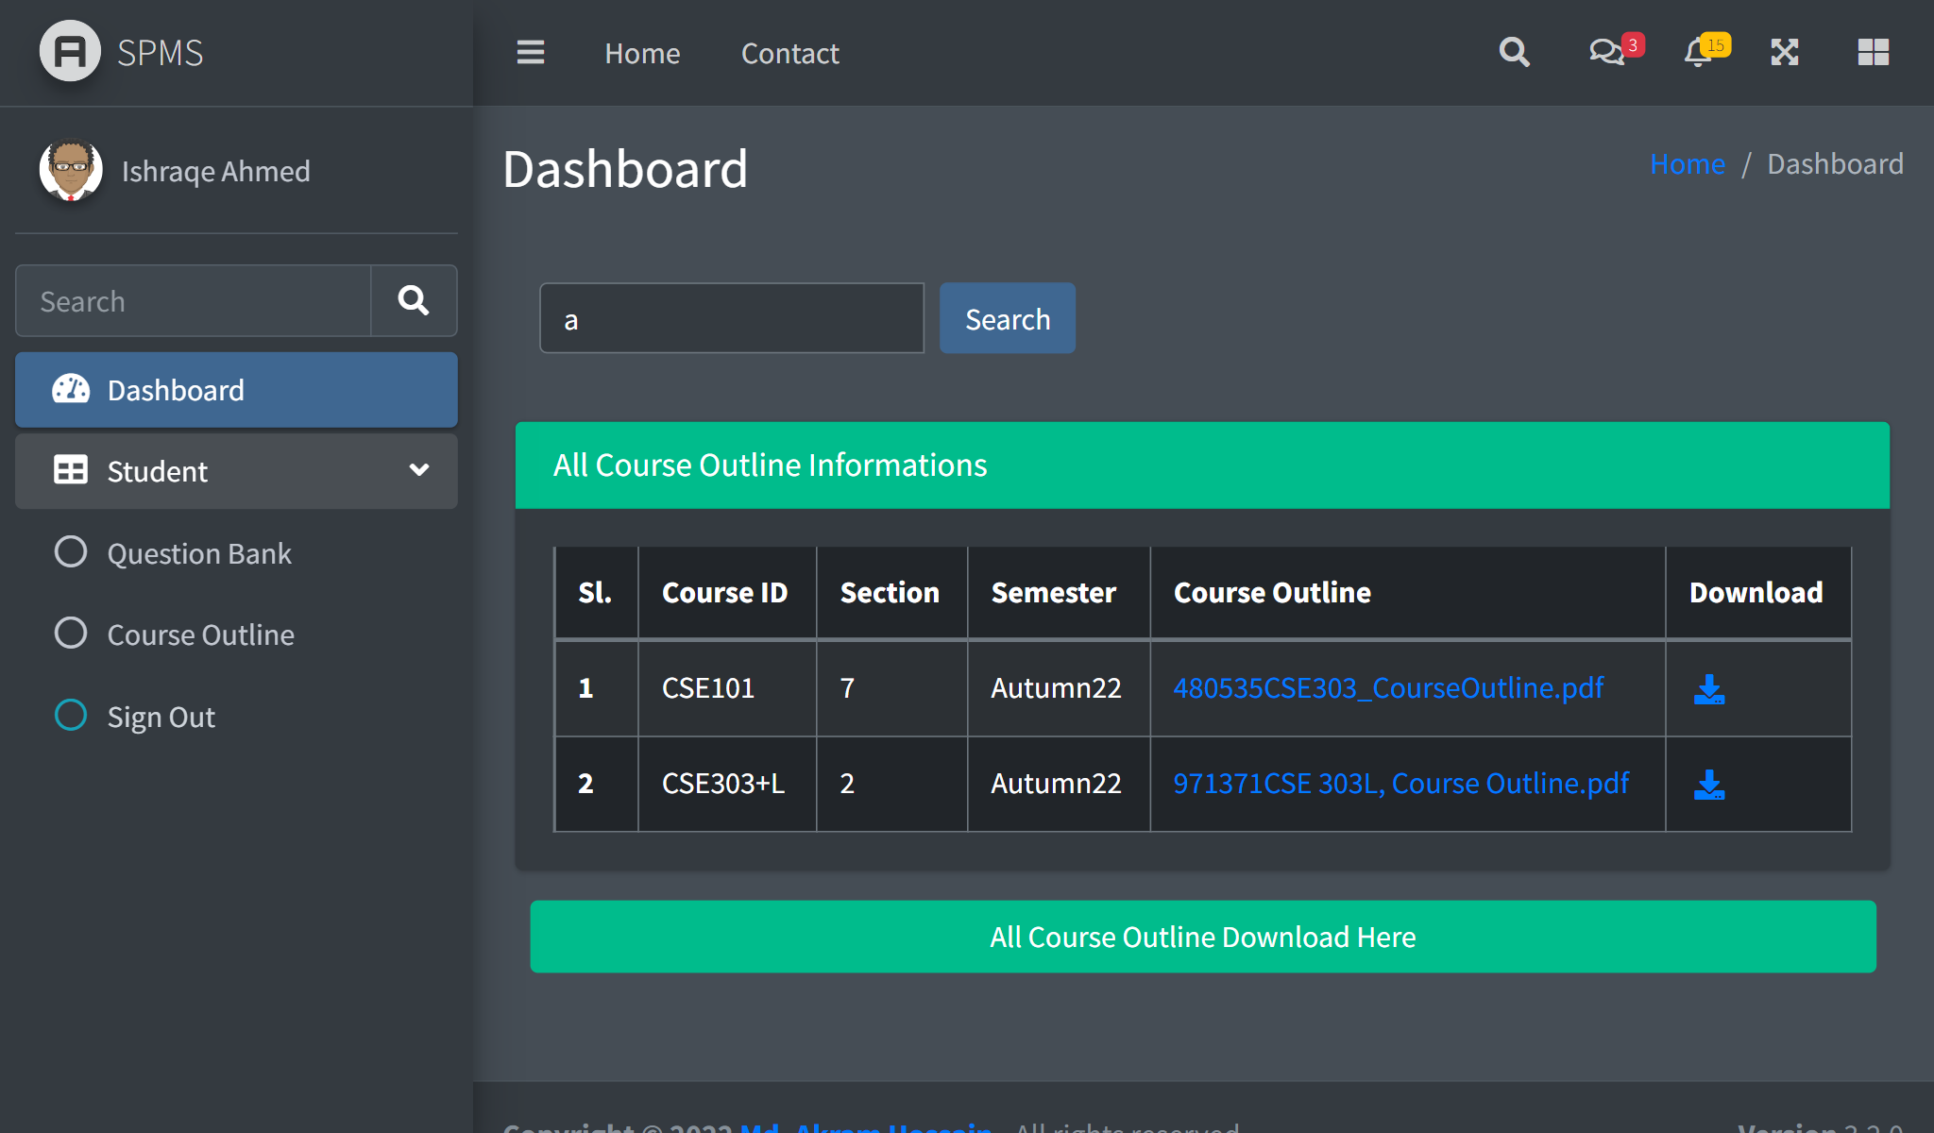

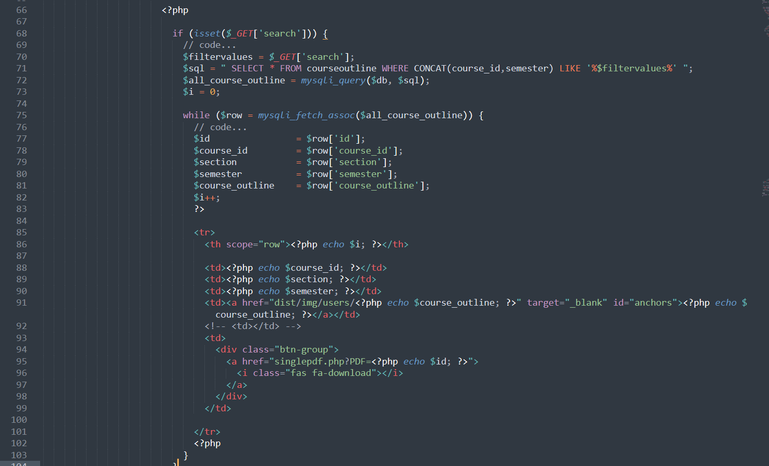

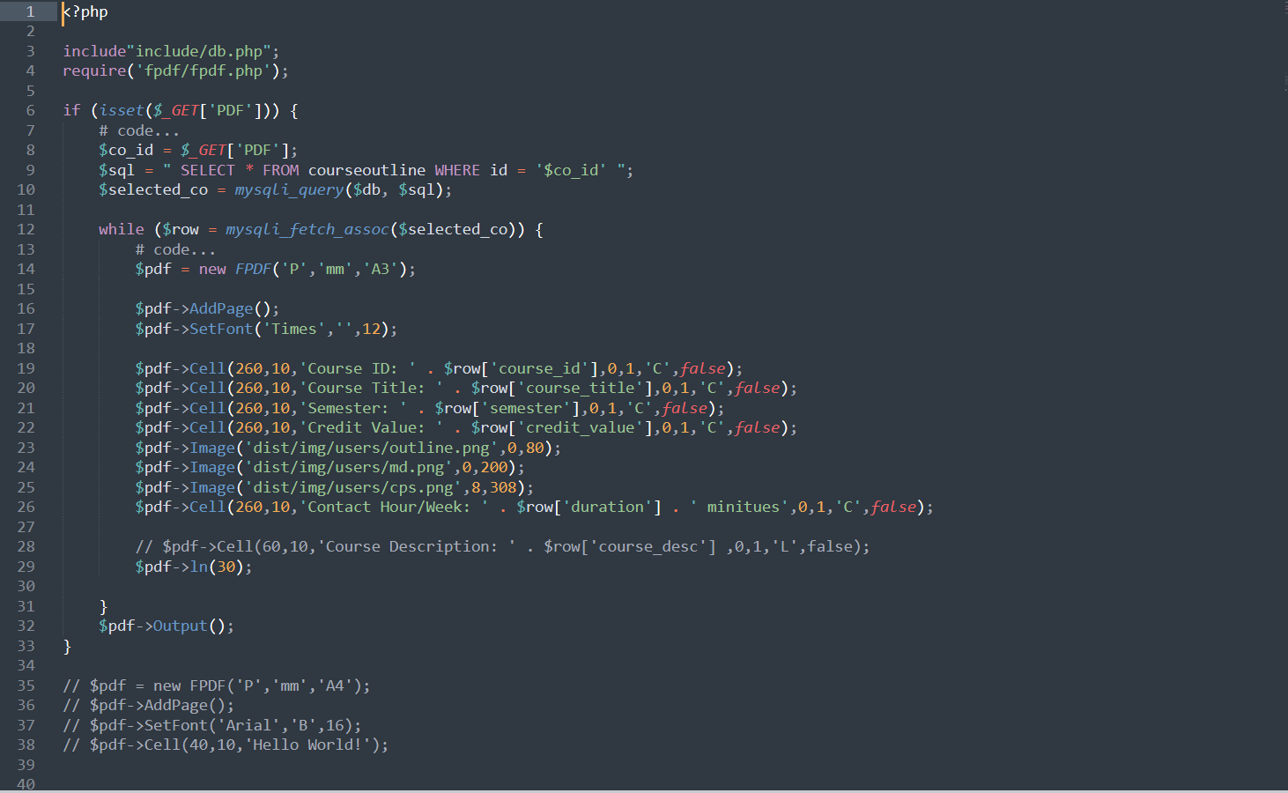

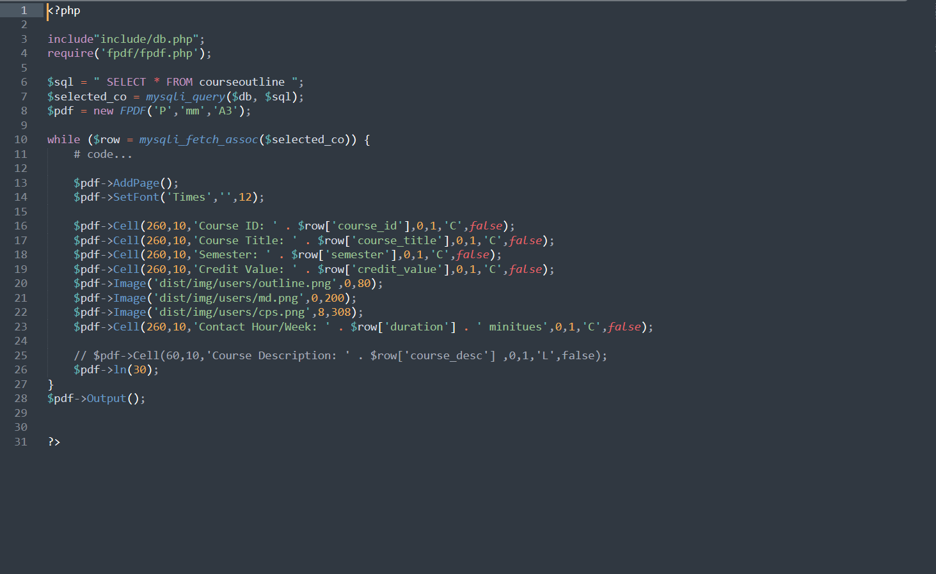

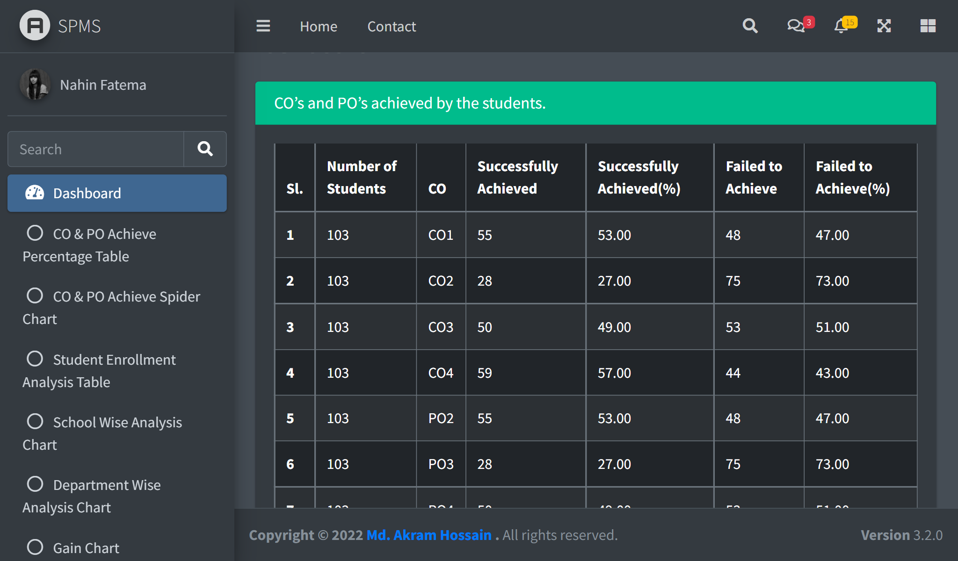

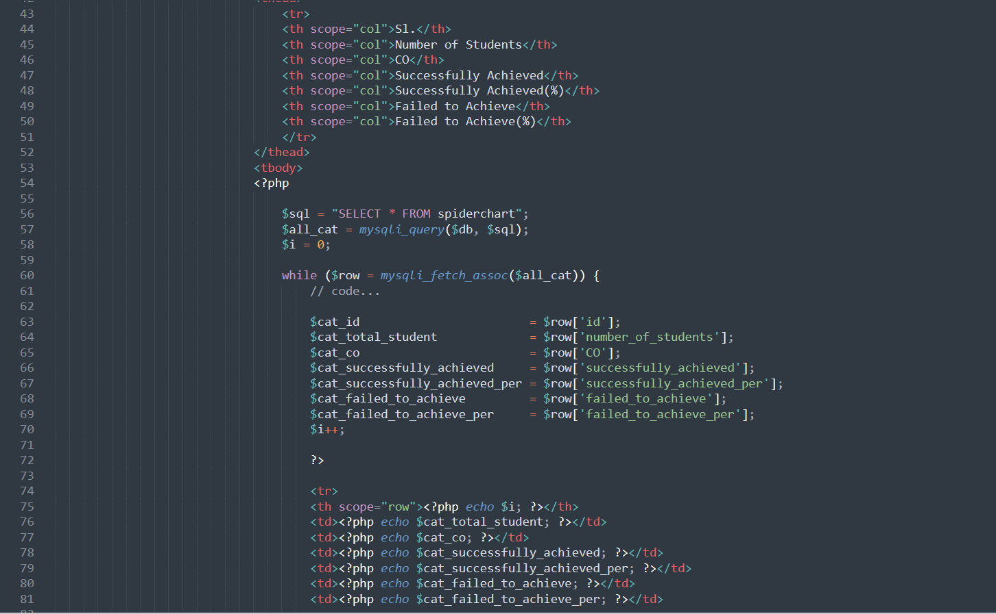

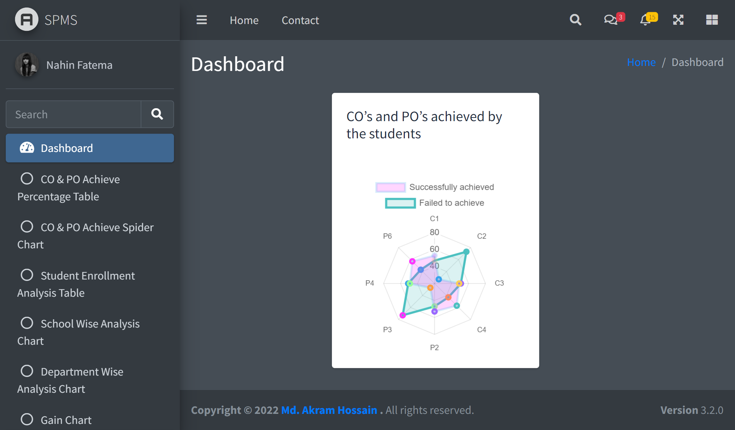

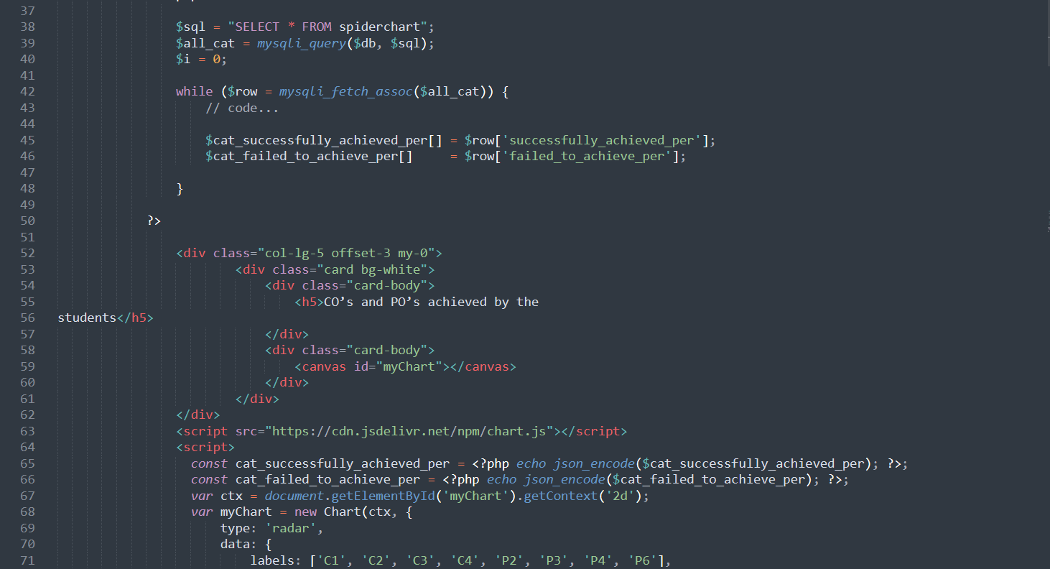

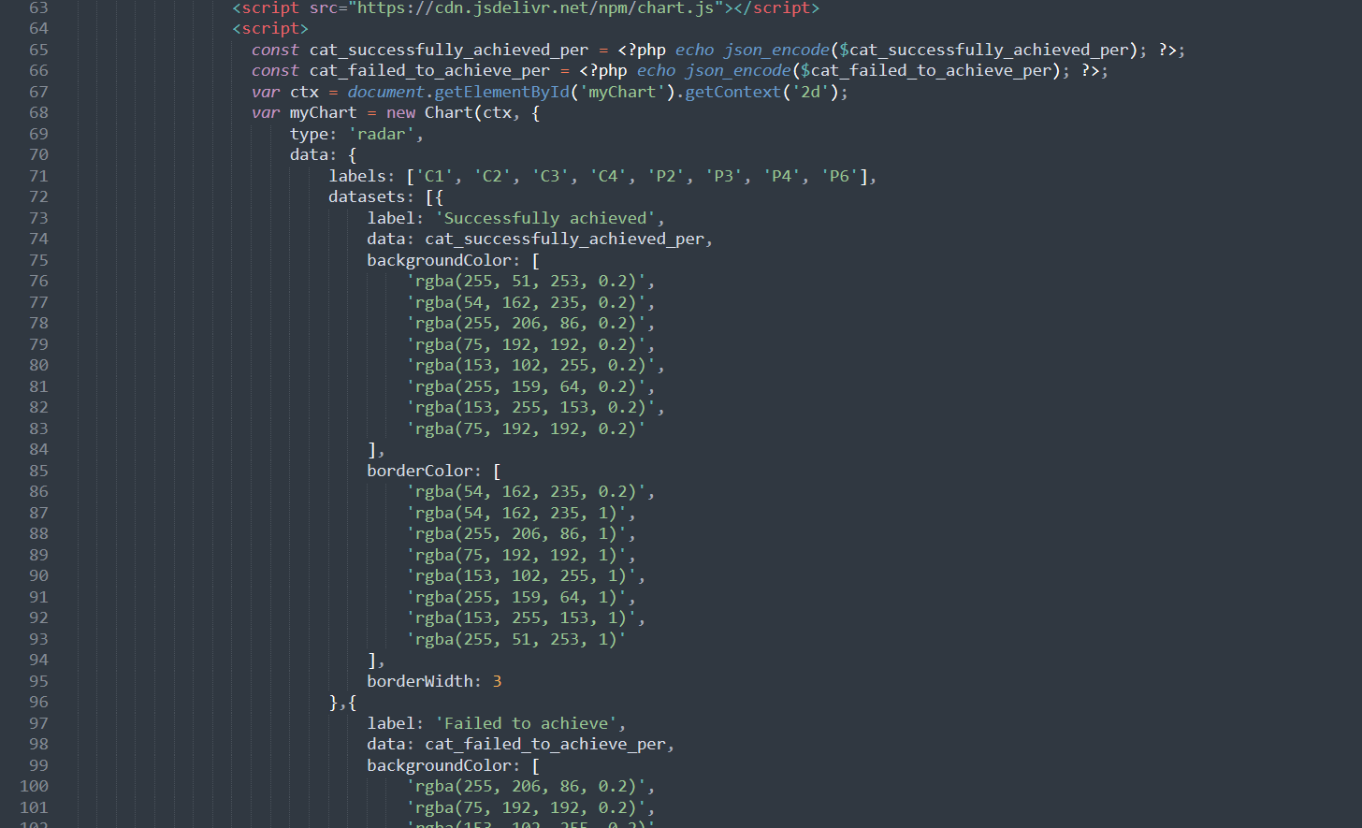

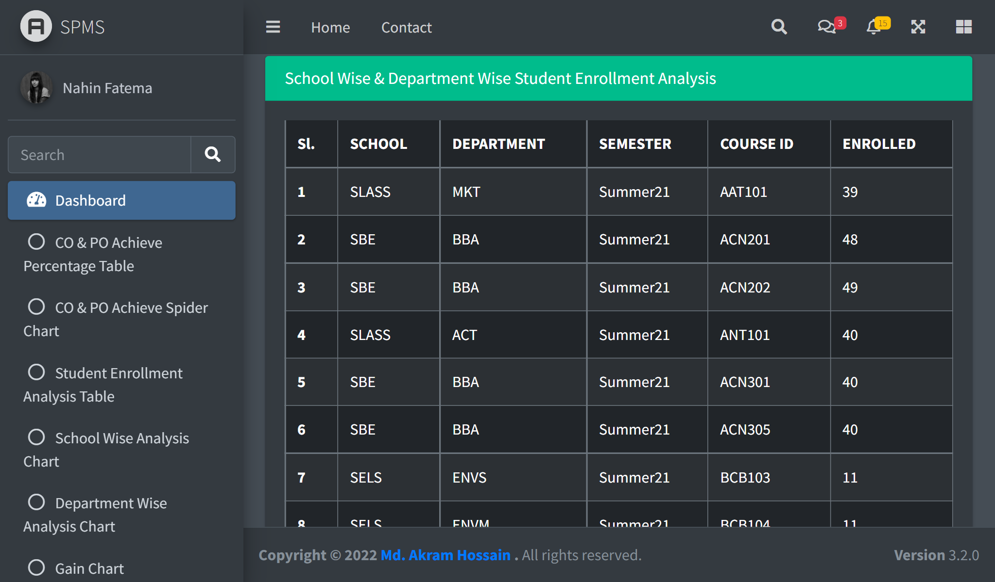

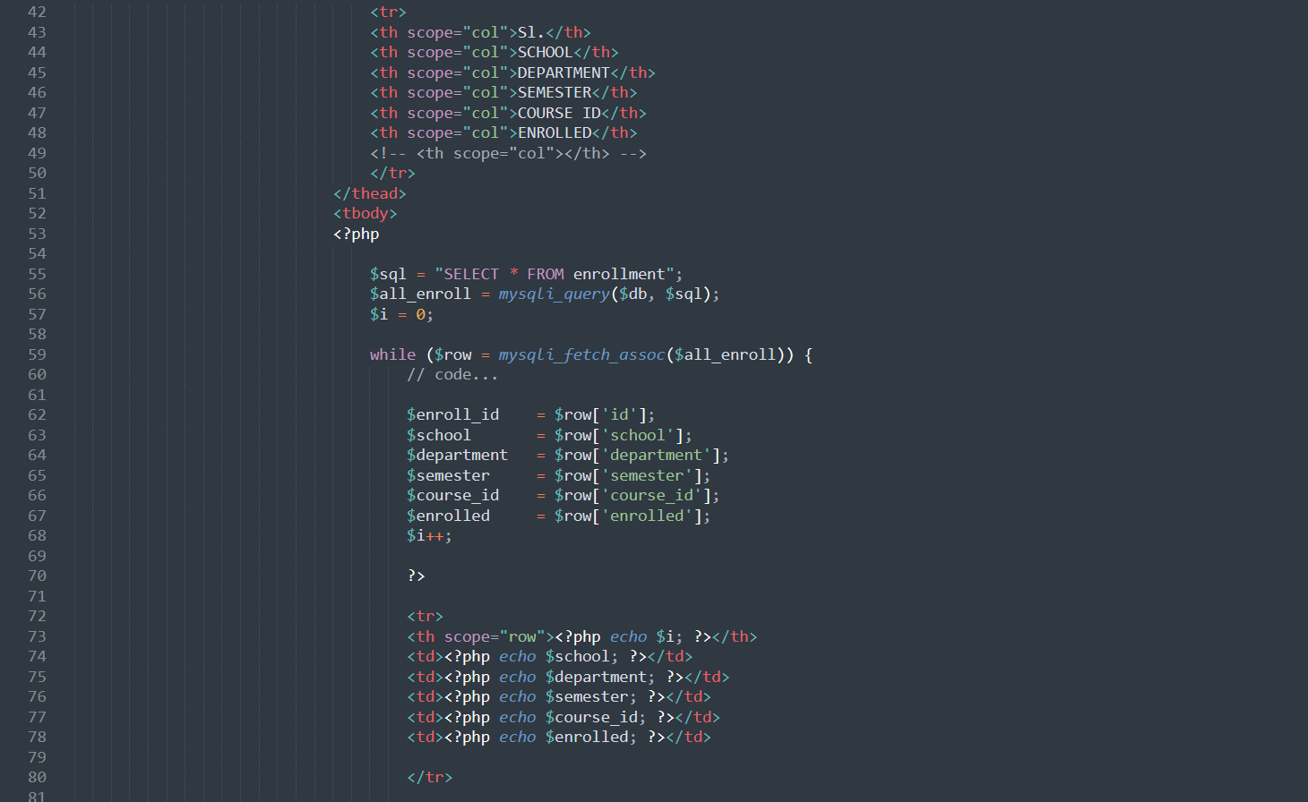

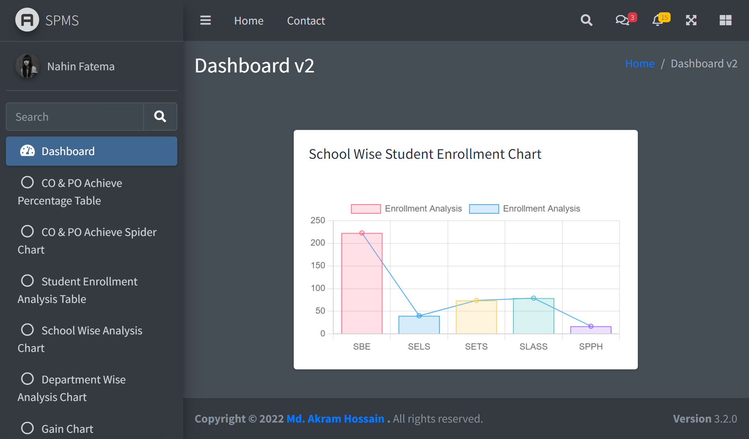

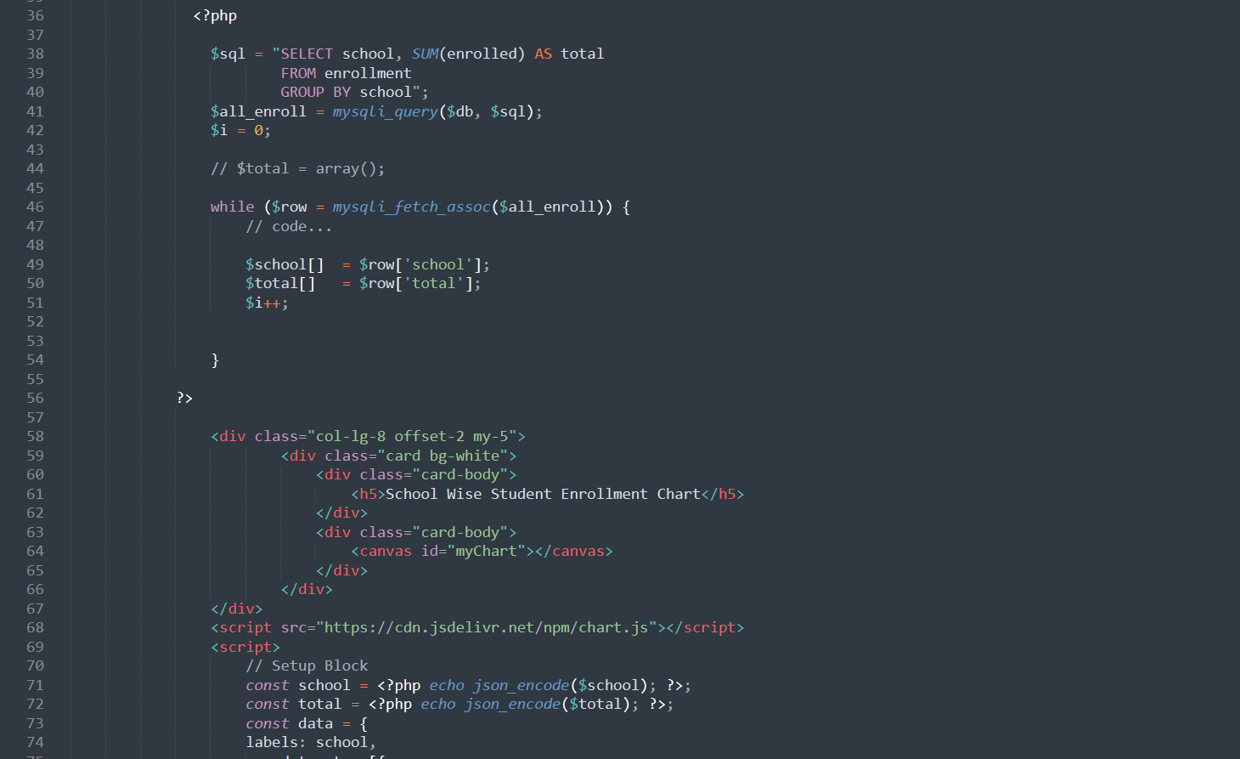

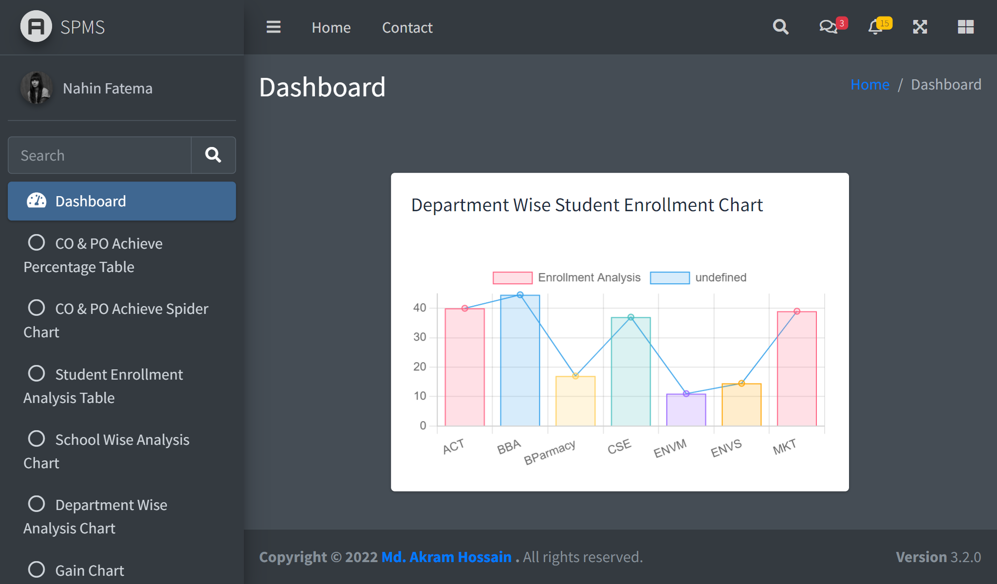

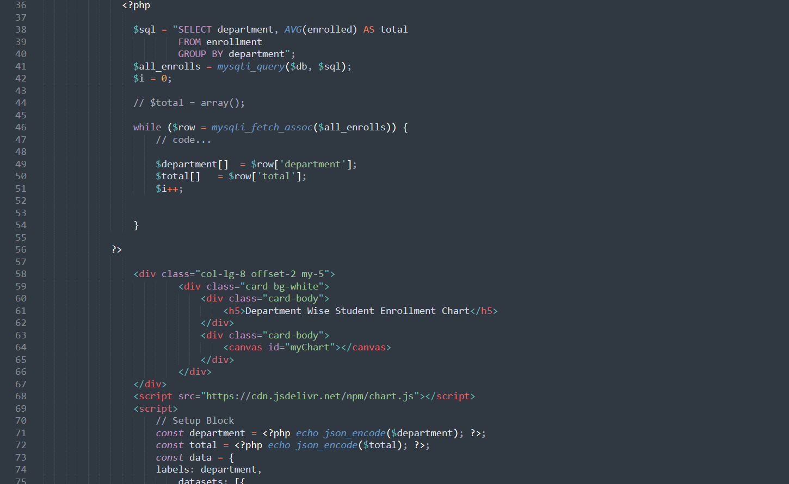

**CHAPTER 5 - CONCLUSION:**

**A. PROBLEM AND SOLUTION:**

**Analysis Phase**

Because there was no discrete data available, the majority of the work assumptions and questions were established when working on the rich picture and six element analysis of the organization's operations. To comprehend the situation better and to avoid it,

There were misunderstandings, respected faculty members, and stakeholder interviews conducted.

**Designing Phase**

The Relational Schema design also included the retention of created entities at their Significant levels based on descriptive study. The instructor's feedback was also highly important and valid in this situation.

**Implementation Phase**

All the Software System Requirements (SSR’s) reached successfully!

Front-End Development tools: HTML, CSS, Bootstrap JavaScript, Chart Js

Back End Development tools: PHP, XAMPP

Database-integration: SQLlite3

**B. ADDITIONAL FEATURE AND FUTURE DEVELOPMENT:**

**Future Developing Purposes:**

* Plans for the project is, to add another feature which can predict A candidate’s grade

based on his/her past grades and performances.

* Difficulty of the current semester can be compared with the previous semester question difficulty percentage.

**REFERENCES-**

[1] Independent University - Bangladesh, "Curriculum for B Sc. in Computer Science and

Engineering (Version 2.2)," Independent University - Bangladesh, March 19, 2017.

[2] Independent University - Bangladesh, "www.iub.edu.bd," 2020. [Online]. Available:

www.iub.edu.bd.

[3] I. Department of Computer Science and Engineering, "Department of Computer Science

and Engineering, IUB," 2020. [Online]. Available: http://www.cse.iub.edu.bd/.

[4] D. o. C. S. &. S. Engineering, "The University of Western Australia," 2006. [Online].

Available: https://teaching.csse.uwa.edu.au/units/CITS3240/Lectures/db-er1-nup4.pdf.

[5] K. Stevens, "BetterEvaluation," 2020. [Online]. Available:

https://www.betterevaluation.org/en/evaluation-options/richpictures.

[6] Wikipedia, "Wikipedia," 2020. [Online]. Available:

https://en.wikipedia.org/wiki/Rich_picture.

[7] Wikipedia, 2020. [Online]. Available:

https://en.wikipedia.org/wiki/Business_Process_Model_and_Notation.